|  |
| --- |
| **PT. BERLIAN SISTEM INFORMASI** |
| **Operating Lease – Collection Process** |
| **USER MANUAL GUIDE** |
|  |
| **VERSION 1.1** |
| **7/12/2016** |

|  |
| --- |
| All material contained in this manual including text, graphics, icons and images contain proprietary and confidential information of PT. Berlian Sistem Informasi and are protected by international intellectual property and other laws. The compilation of all text, graphics, icons and images in this Manual is the exclusive property of PT. Berlian Sistem Informasi. No modification, rental, lease, sale, transmission, distribution, reposting or creation or derivate works based on the material in this Manual is allowed, unless with the express permission of PT. Berlian Sistem Informasi. |

# REVISION HISTORY

|  |  |  |  |
| --- | --- | --- | --- |
| Date | Revision | Description | Author |
| 3/28/2016 | 0.0 | Initial Document | Sabilla Pravita Larassati |
| 5/26/2016 | 0.1 | Update Capture | Sabilla Pravita Larassati |
| 5/28/2016 | 0.2 | Update Capture | AR. Anggun Cahyaningtyas |
| 5/30/2016 | 0.3 | Update Document | Sabilla Pravita Larassati |
| 5/30/2016 | 1.0 | 1st Baseline | Grand Zah Putra |
| 7/12/2016 | 1.1 | Update document after training section | AR. Anggun Cahyaningtyas |

# TABLE OF CONTENT

REVISION HISTORY 2

TABLE OF CONTENT 3

COLLECTION MODULE 4

1. Monitor Billing Schedule 5

1.1 Edit Billing and Payment History Inquiry 13

1.2 Create Invoice 15

1.3 Create Promise to Pay 18

1.4 Billing and Payment Invoice Approval Path 19

1.4.1 Delivery Invoice Document 22

1.4.2 Invoice Approval 23

1.4.3 Print Invoice Form 24

1.4.4 Print List of Invoice Report 29

1.5 View Billing and Payment History Inquiry 30

1.5.1 Add Billing Payment History Inquiry 32

1.6 Create RAL 34

2. Monitor Billing Overdue 36

2.1 Create Reminder Memo 38

2.2 Create Warning Letter 40

3. Print Billing (schedule/overdue) History 42

4. Manage Warning Letter 44

4.1 Warning Letter Approval 46

4.2 Print Warning Letter Form 48

4.3 Warning Letter History 50

4.4 Print Warning Letter Report 51

5. Manage RAL 53

5.1 RAL Approval 55

5.2 Print RAL Form 58

5.3 RAL History 60

5.4 Print RAL Report 61

# COLLECTION MODULE

Operating Lease Support System consist of Procurement Process, Collection Process, Maintenance Process, and Collection Process. All features will be described in the subsequent sections. The Collection menu of Operating Lease Support System serves as the continuation of Unit Management process, and Maintenance Process. With the Collection menu, you will be able to monitor and edit billing payment, create invoice and monitor invoice progress, input payment history on monthly base, manage RAL, and manage warning letter.

Additionally you can enter new record, make changes, and inspect a detail record, and also filter specific records based on columns by writing a keyword on the search field. The features and data contained in your Operating Lease Support System menu are limited by your security and data authorization settings so you may not be able to access all features.

Only authorized user have access to all records in order to keep them up to date. Collection modules provides following functions:

1. Monitor billing payment schedule before due date.
2. Monitor billing payment after due date.
3. Filter and sort a data that appears on the list. To do this function user can do as follows:

* Click  to sort a record ascending or descending.
* Filter a numbers of records by selecting 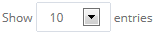.
* Filter records by input keywords at 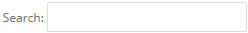.

# Monitor Billing Schedule

Screen of **Monitor Schedule** will be used by PIC collection to monitor payment billing on monthly base. After BAST DSF to customer has been conducted, billing will automatically generate and displayed in **Monitor Schedule** screen. Using this feature, user can monitor billing schedule, edit billing, create invoice, and send reminder mail to customer. Monitor will be based on end of period usage unit date (monthly date) and due date.

At the beginning, user can open **Monitor Schedule** Screen by clicking the “**Monitor Schedule**” on the **Collection** menu. Once clicked the menu, system will display the **Monitor Schedule** page. When opening the page it may look as following:

1. Navigate to Collection menu and click “**Monitor Schedule**”.

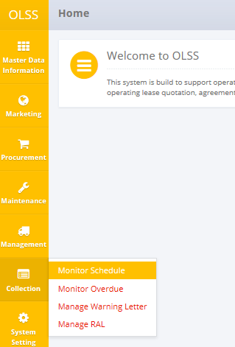

Screen 1: Collection Menu – Monitor Schedule

1. System will show **Monitor Schedule** screen that consisted of agreement that approaching due date or agreement that already reach end contract. The main page of **Monitor Schedule** is shown below:

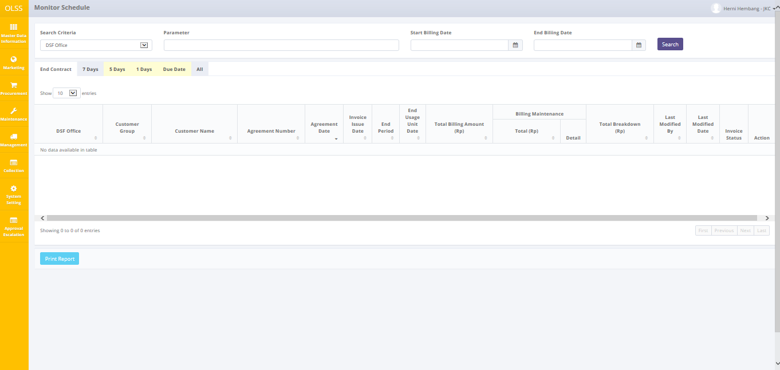

Screen 2: Monitor Schedule Screen

On **Monitor Schedule** screen, there are 6 tabs in total, which are:

* 1. Tab End contract, display agreement on last month billing payment to end contract.
  2. Tab 7 days, display agreement number with status “Open” that has remaining 7 days before end usage unit date.
  3. Tab 5 days, display agreement number with status “Open” that has remaining 5 days before due date.
  4. Tab 1 day, display agreement number with status “Open” that has remaining 1 day before due date.
  5. Tab Due Date, display agreement number with status “Open” that already reach due date.
  6. Tab all; display all agreement number with status “Open”.

Each tab gives different function. There are 3 buttons that will be displayed on tab End Contract, which are:

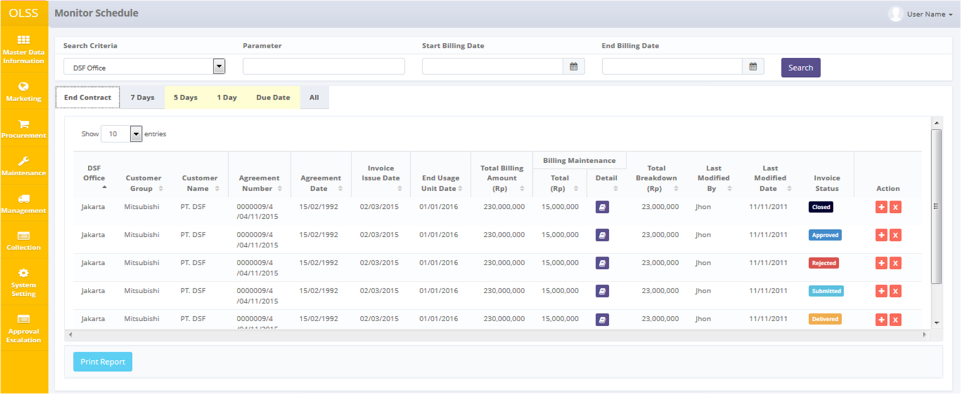

Screen 3: Monitor Schedule Screen – Tab End Contract

1. Billing maintenance detail: view maintenance on billing period. Only enabled if agreement maintenance type is CSD.
2. Create RAL: Create Return Authorization Letter for customer.
3. Stop Billing  : Change contract status from OPEN to STOP BILLING. Agreements with status STOP BILLING cannot be changed or do any action (all buttons are disabled).

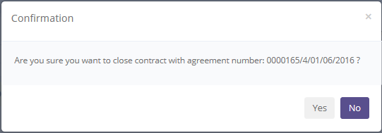

Screen 4: Stop Billing Confirmation Pop up



Screen 5: Stop Billing Success Notification

1. 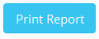: Print list of agreement based on specific search.

On Tab 7 days, there are 6 buttons which are:

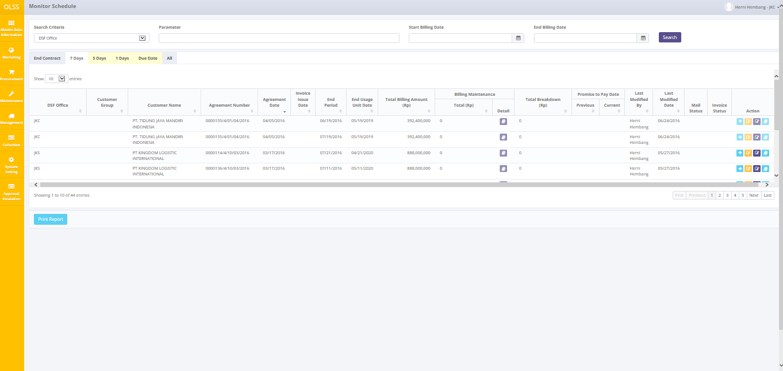

Screen 6: Monitor Schedule Screen – Tab 7 Days

* 1. Billing Maintenance Detail: view maintenance amount and information for each unit leased in monthly basis. Only enabled if agreement maintenance type is CSD. Below is the billing maintenance detail screen:

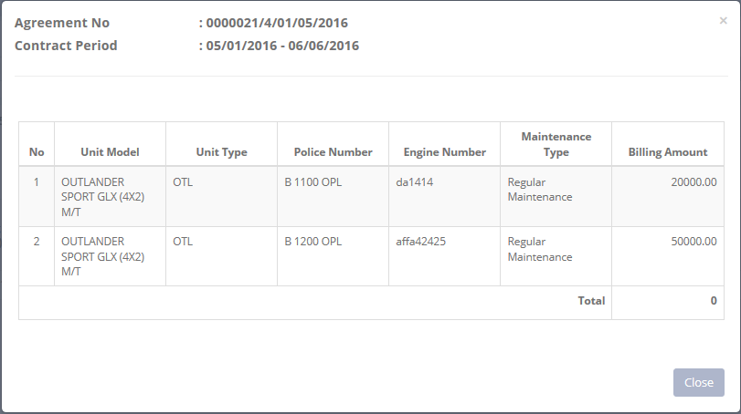

Screen 7: Billing Maintenance Detail Pop up Screen

* 1. Create Invoice: create new invoice and receipt on selected agreement.
  2. Edit Billing Payment: edit billing of payment history inquiry.
  3. Input Promise to Pay: input date of promise date.
  4. Billing Payment History Inquiry Invoice: to navigate invoice document and approval path.
  5. : Print list of billing payment based on specific search.

Tab 5 days and 1 day have different buttons than tab 7 days, the buttons are:

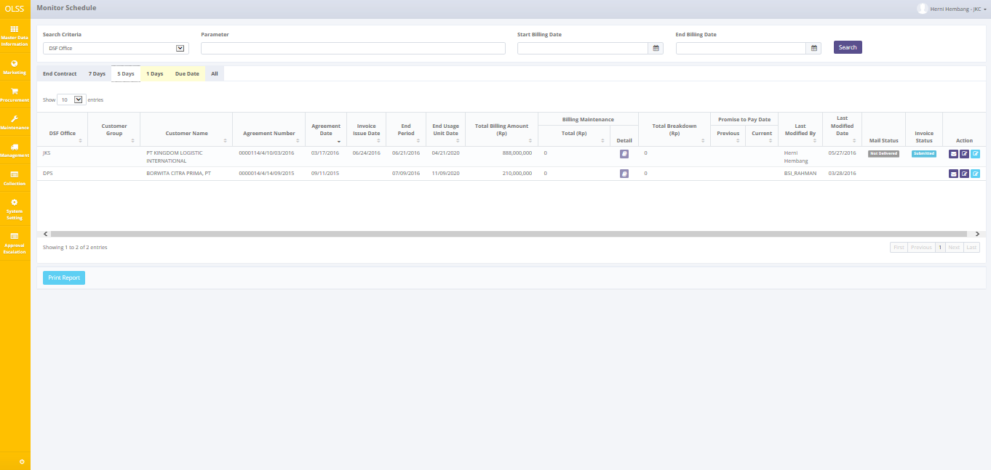

Screen 8: Monitor Schedule – Tab 5 Days

1. Billing Maintenance Detail: view maintenance amount on billing period. Only enabled if agreement maintenance type is CSD.
2. Send reminder email: click to send reminder before due date. Notification will show upon successful sending. Below is the success notification after the email is successfully sent:

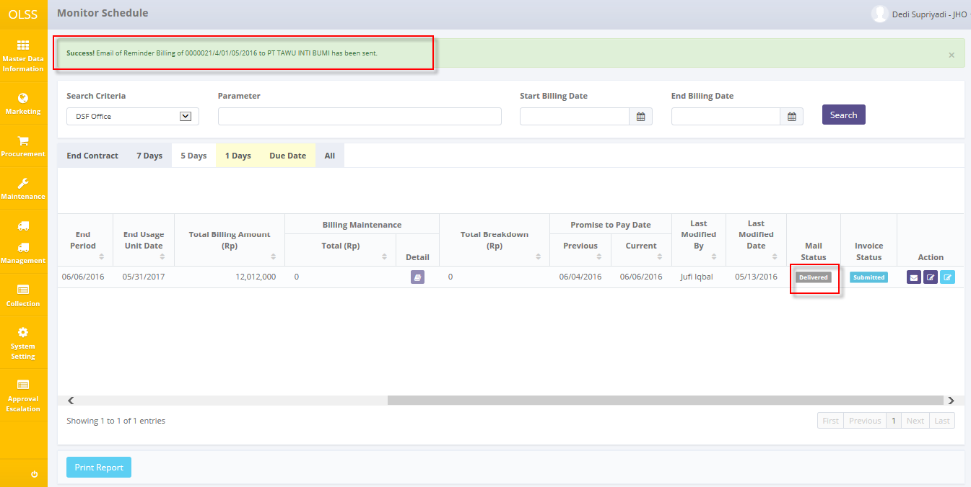

Screen 9: Reminder Email Success Notification

1. Input Promise to Pay: input date of promise date.
2. View Billing & Payment History Inquiry: view billing payment information, can navigate to Add Partial Billing Payment screen.
3. : Print list of billing report based on specific search.

On Tab Due Date, there are 3 buttons which are:

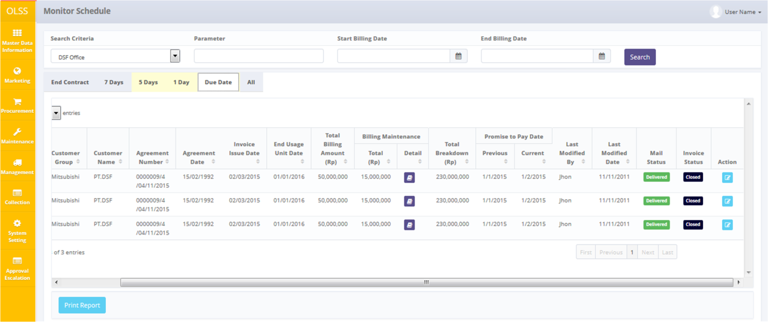

Screen 10: Monitor Schedule Screen – Tab Due Date

* 1. Billing maintenance detail: view maintenance on billing period. Only enabled if agreement maintenance type is CSD.
  2. Edit billing and payment history inquiry: view billing payment information, can navigate to Add Partial Billing Payment screen.
  3. : Print list of agreement based on specific search.

On Tab all, there are 7 buttons which are:

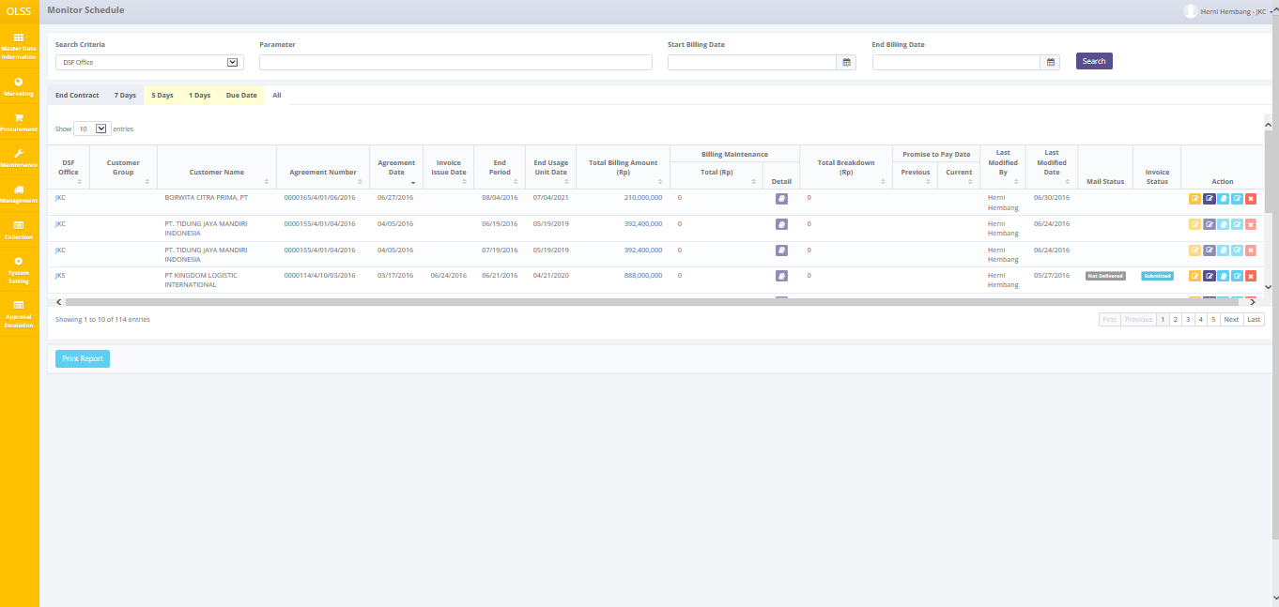

Screen 11: Monitor Schedule – Tab All

1. Billing Maintenance detail: view maintenance on billing period. Only enabled if agreement maintenance type is CSD.
2. Edit Billing Payment: edit billing of payment history inquiry.
3. Input Promise to pay: input payment date.
4. Billing Payment History Inquiry Invoice: to navigate invoice document and approval path.
5. Billing and payment history inquiry: view billing payment information, can navigate to Add Partial Billing Payment screen.
6. Stop Billing  : Change contract status from OPEN to STOP BILLING. Agreements with status STOP BILLING cannot be changed or do any action (all buttons are disabled).
7. : Print list of agreement based on specific search.

On the right view of **Monitor Schedule** screen, there are two columns with status in it; the first column is **Mail Status** and the second one is **Invoice Status**. **Mail status** has two statuses which are:

1. , means the reminder email has been sent to customer email.
2. , means the reminder email hasn’t been sent to customer email.

While Invoice Status has 6 statuses which are:

1. , means the invoice has been created but not submitted yet.
2. , means the invoice has been submitted by PIC collection. Need to be checked by DSF authorized user.
3. , means the invoice has been checked by DSF authorized user, and continues to the next approval hierarchy.
4. , means the invoice document has some mistakes. Document that has been revised need to be submitted back by PIC collection.
5. , means the invoice has been approved by DSF authorized user.
6. , means the invoice hardcopy has been delivered to customer.

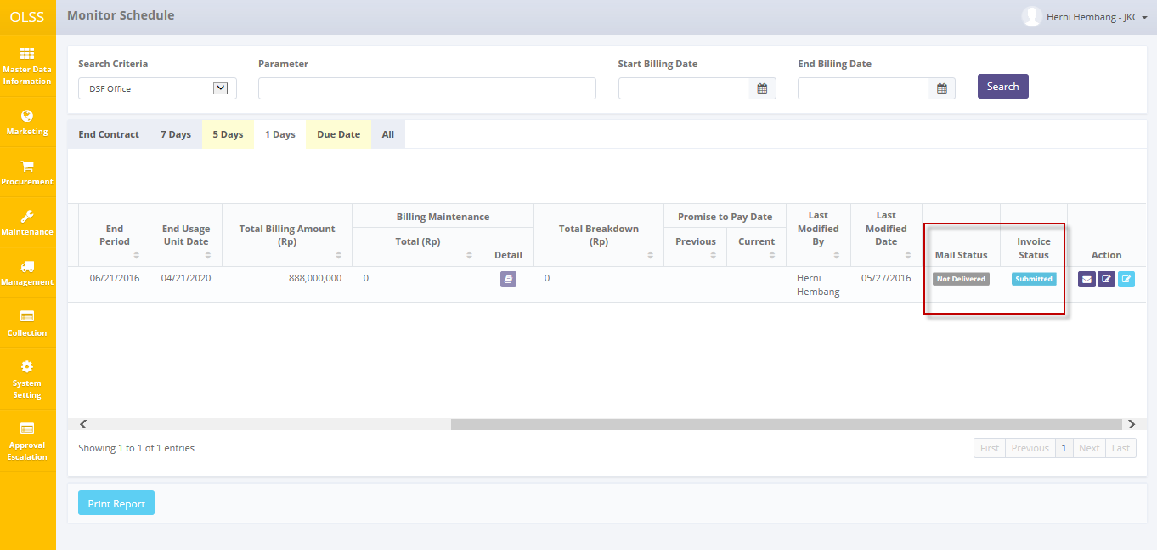

Screen 12: Monitor Schedule Screen – Status

## Edit Billing and Payment History Inquiry

Before user create invoice to customer, user can edit the billing in case there is any information to be change. To edit billing and payment, there is more than one way. First, navigate to **Monitor Schedule** screen – Tab 7 days / Tab All. Processes can be seen below:

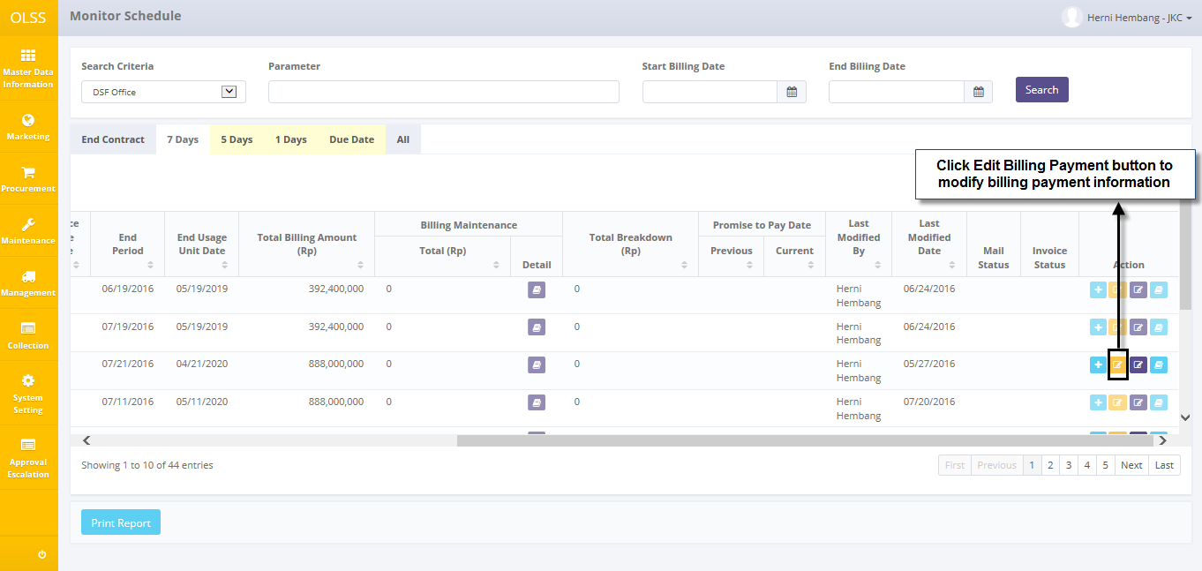

Screen 13: Navigate to Edit Billing & Payment History Inquiry screen

System will display **Edit Billing and Payment History Inquiry** screen.

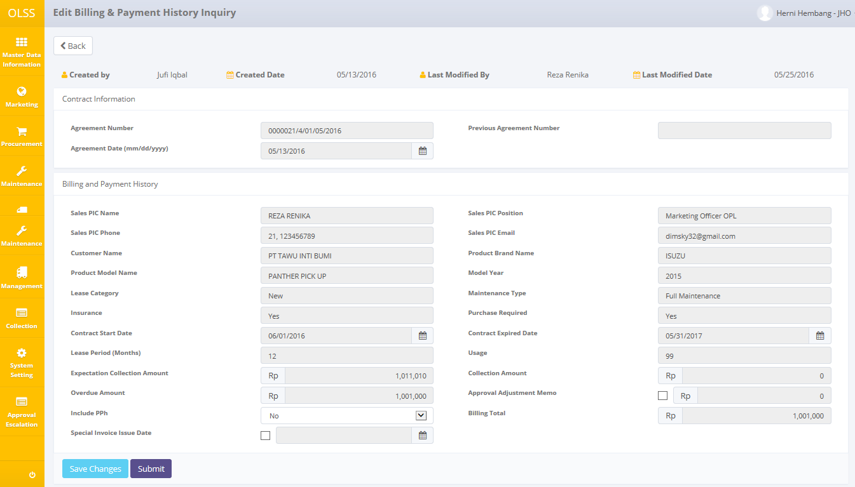

Screen 14: Edit Billing & Payment History Inquiry Screen

There are three buttons that will be displayed on the screen as follows:

1. 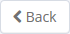, to go back to previous screen; Monitor Billing Schedule.
2. , to update billing payment.
3. 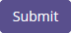, to save billing payment information that has been fixed.

There are information fields on top of the screen, consist of the user information that created the document and had make changes to the records. In here user can view contract information, customer information, lease category, maintenance type, and collection amount. If the agreement use breakdown, user can check **approval adjustment memo**, then **breakdown adjustment amount** textbox will active. If customer requests to pay the billing on specific date, user can check **special invoice issue date**, and then date of **issue date** will be active and required.

If data already changed on the screen, user can save data on the system by clicking **Save Changes** button. After clicking **Save Changes**, confirmation pop-up dialog will show up. Click yes to save document.

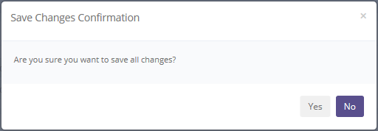

Screen 15: Save Changes Confirmation Pop up

System will notified if it success or failed to save changes.

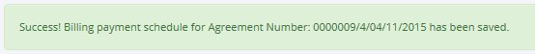

Screen 16: Edit Billing Payment Success Notification

## Create Invoice

Invoice can be created once the agreement has reached 7 days before due date or special case agreement where customer request to pay on specific date. If user wants to create Invoice receipt, please follow procedures shown below:

1. Navigate to **Monitor Schedule** screen - tab 7 days.
2. On 7 days tab, click Create Invoice button. Only agreement with 7 days before end of usage unit or with special condition for invoice date can be created invoice and receipt. System will display Create Invoice screen.

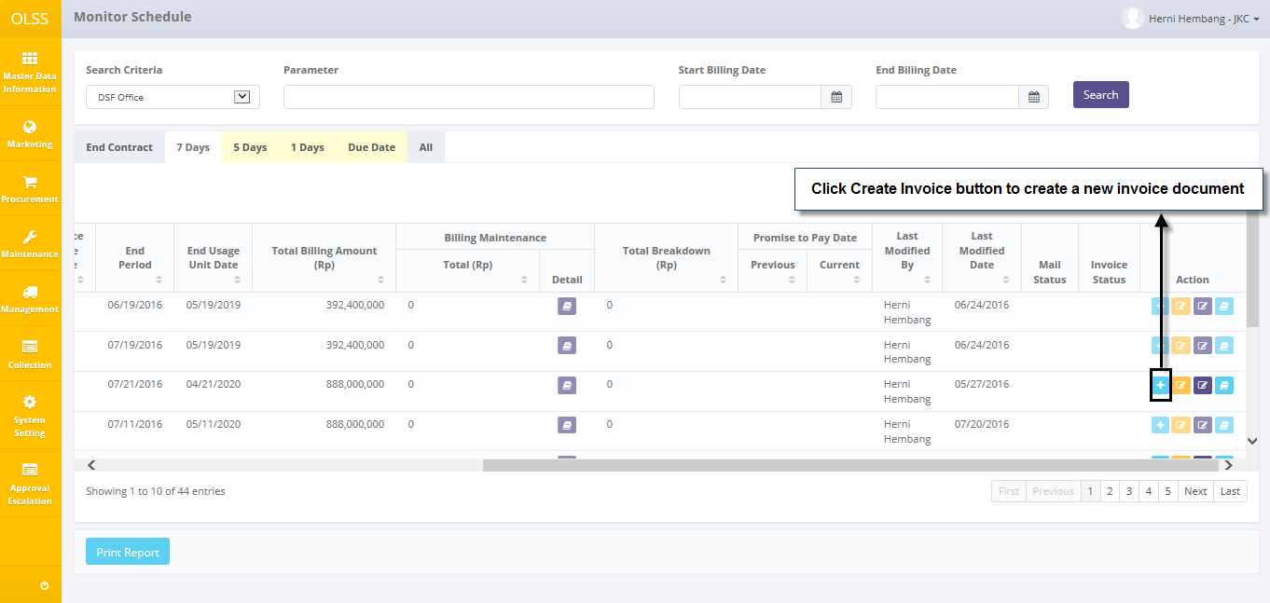

Screen 17: Monitor Schedule Screen – Create Invoice button

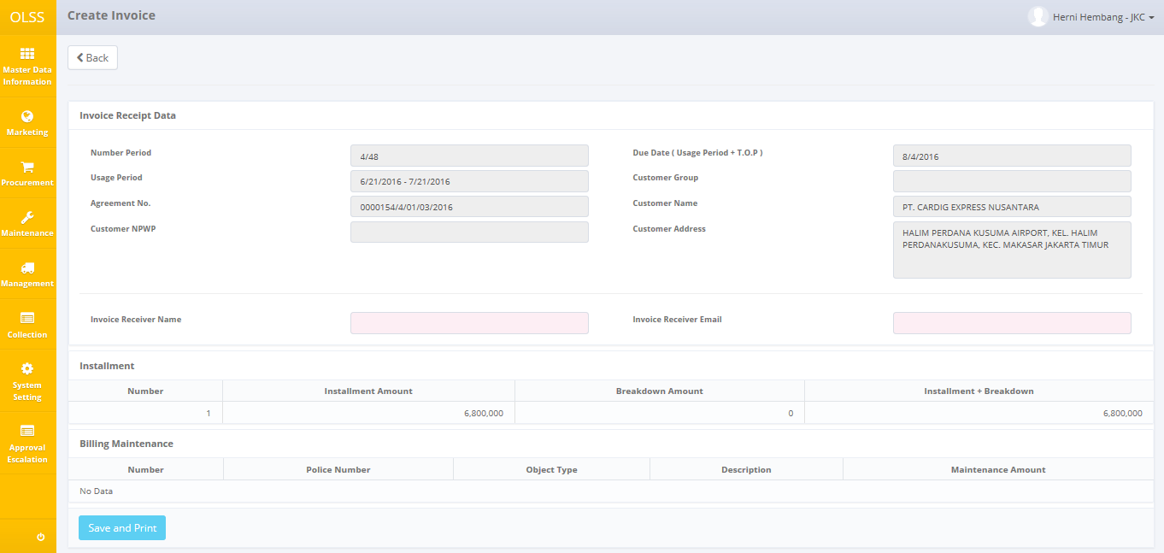

Screen 18: Create Invoice Screen

Once Create Invoice screen opened, there are 2 buttons displayed:

1. 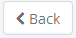: click the button to go to previous screen which is Monitor Schedule.
2. 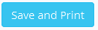: click the button to save document and print invoice receipt.

To start creating Invoice, please input following fields with necessary information:

* 1. Invoice Receipt Date
* Number period: automatically show month payment/period. Example: 4/12 = 4 refer to invoice for fourth month, and 12 refer to agreement period.
* Usage period: automatically show calendar days 1 – 30/31 monthly.
* Agreement no: automatically show agreement number.
* Customer NPWP: automatically show customer NPWP
* Due date (Usage period + T.O.P): automatically show agreement due date for current month.
* Customer Group: automatically show customer group.
* Customer Name: automatically show customer name.
* Customer address: automatically show customer address.
* Invoice receiver name: input receiver name.
* Invoice receiver email: input receiver email address.
  1. Installment
* Installment amount: display installment amount.
* Breakdown amount: display breakdown amount.
* Installment + breakdown: display total payment amount.
  1. Maintenance
* Police number: display unit police number.
* Object type: display unit type.
* Description: display unit description.
* Maintenance Amount: display maintenance amount.

User can save data on the system by clicking  button. There are several mandatory fields that should be inputted before clicking the button. If user leaves it blanks or wrong, system will notified it as error message. Clicking  button will display Pph pop-up dialog that asks user if the invoice is includes Pph or not.

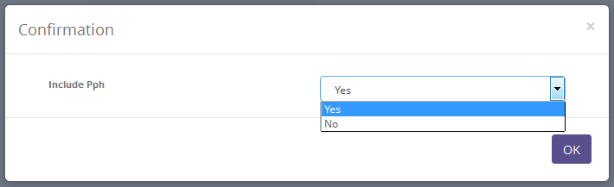

Screen 19: Invoice Pph Confirmation Pop up Dialog

After choosing Yes or No in Pph confirmation screen, system will display Invoice Creation confirmation screen as follows:

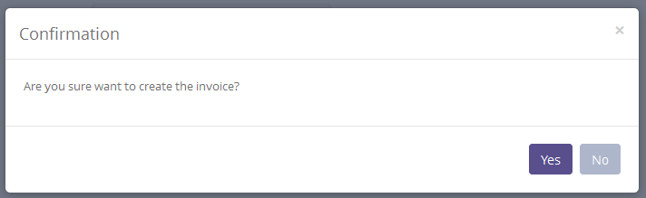

Screen 20: Invoice Confirmation Pop up Dialog

Click **yes** to continue. System will notified if it success or failed to save.

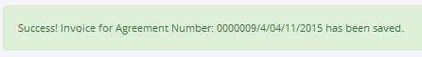

Screen 21: Invoice Creation Success Notification

System will automatically send email to customer and print invoice receipt containing:

* Installment invoice
* Installment receipt
* Maintenance invoice
* Maintenance receipt
* Receive letter

## Create Promise to Pay

After user have sent the invoice or remind customer for payment, user can input the postponed payment date in system by using feature **Promise to Pay**. Please follow procedures shown below:

* 1. Navigate to **Monitor Schedule** screen, find tab 7 days/5 days/1 day/all.
  2. Click input **Promise to Pay** button on selected agreement.

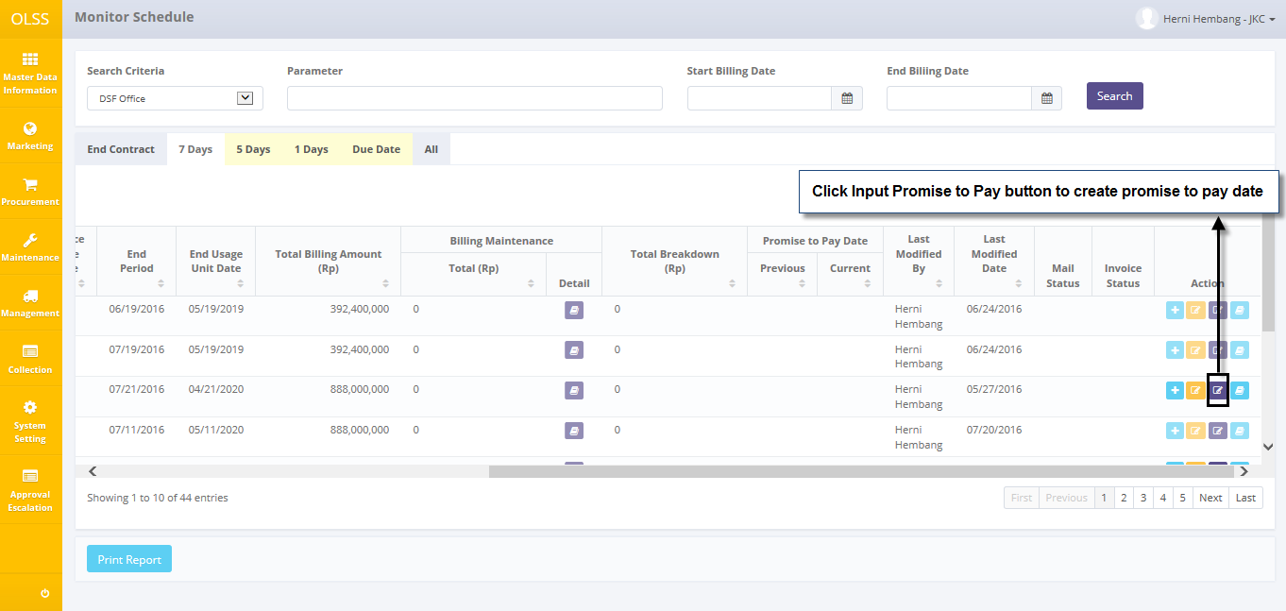

Screen 22: Monitor Schedule Screen – Promise to Pay button

* 1. System will display **Promise to Pay** pop up screen.

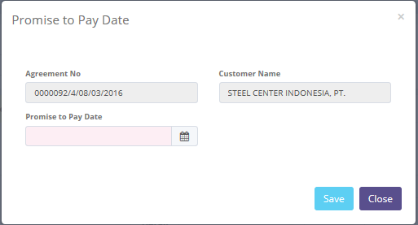

Screen 23: Promise to Pay Pop Up Screen

Once **Promise to Pay** screens pop up, there are 2 buttons displayed:

1. 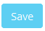: click the button to save promise payment date.
2. 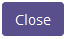: click to close the pop up screen.

To update **Promise to Pay** date, fill information field as follows:

1. Agreement no: automatically display agreement number.
2. Customer name: automatically display customer name.
3. Promise to pay date: select Promise to pay date.

User can save data on the system by clicking Save. System will automatically go back to **Monitor Schedule** screen. Success notification will show on top of the screen.

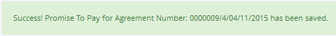

Screen 24: Promise to Pay Success Notification

## Billing and Payment Invoice Approval Path

Billing and payment invoice approval path holds information for contract information, billing and payment history, and invoice list. In invoice list, there are listed each invoice amount and maintenance invoice on monthly basis. To view Billing and Payment Invoice Approval path, click **Billing Payment History Inquiry Invoice** button on Monitoring Schedule screen. System will display **Billing & Payment Invoice Approval Path** screen.

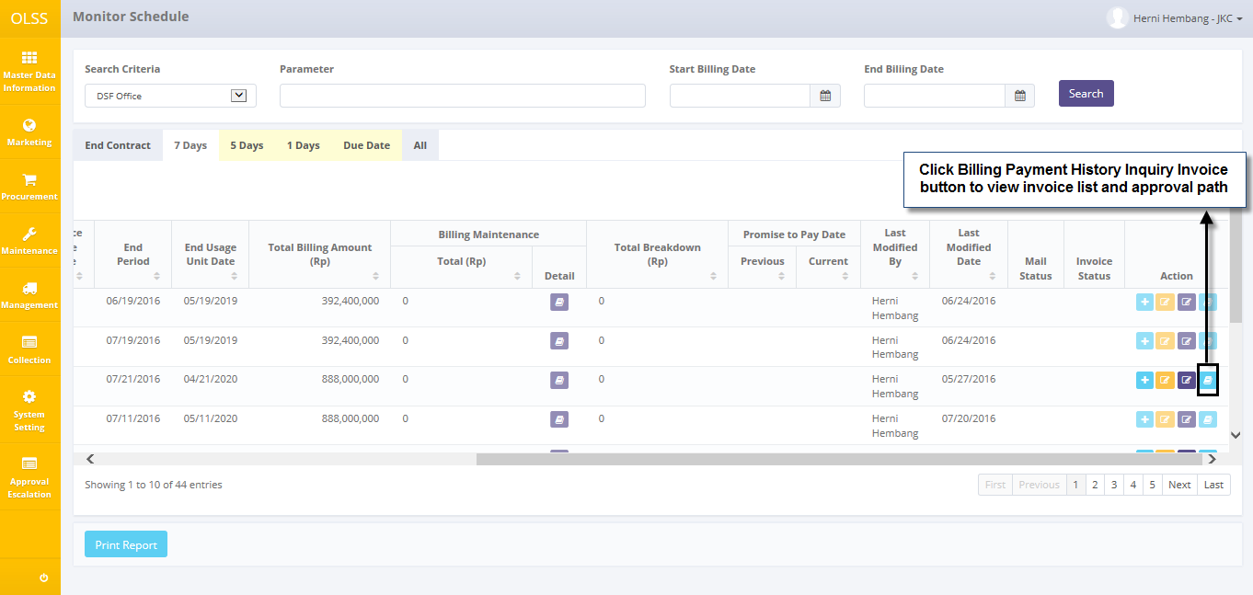

Screen 25: Monitor Schedule screen – Billing Payment History Inquiry Invoice

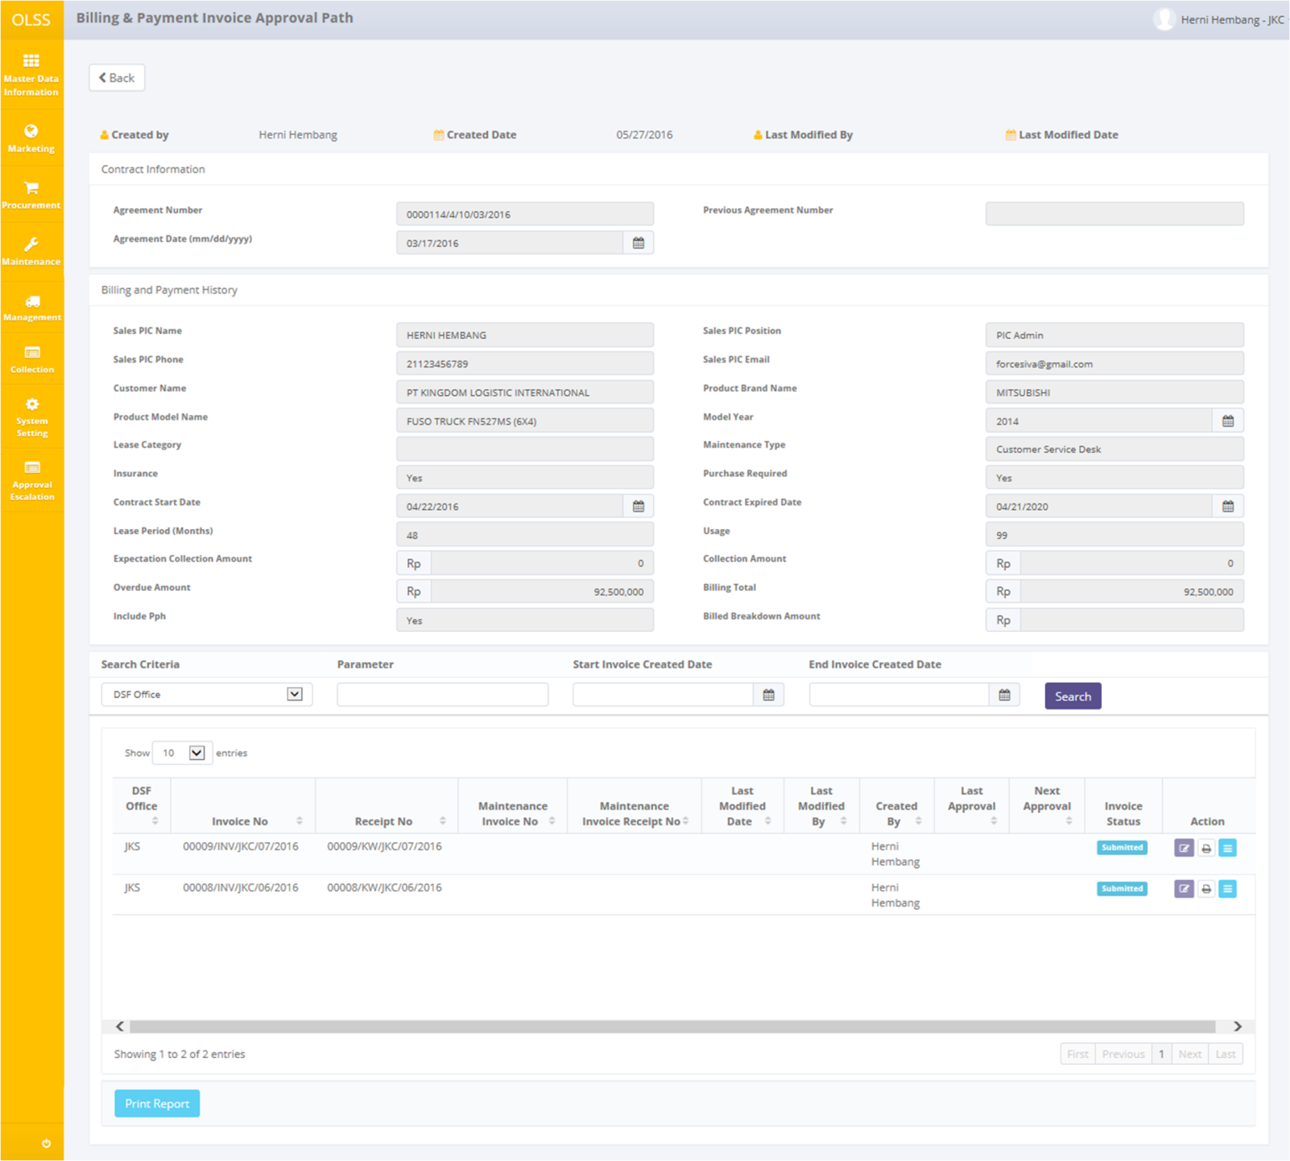

Screen 26: Billing and Payment Invoice Approval Path Screen

There are 5 buttons displayed, which are:

1. : To go to previous screen; which is Monitor Schedule screen.



1. Invoice Delivery: input invoice delivery date information.
2. Print: Print invoice form for selected invoice.
3. Detail Invoice: navigate to Invoice Status approval.
4. : print invoice list report.

### Delivery Invoice Document

User can use this feature to input information about invoice delivery. Click the button to access **Delivery Invoice Document** screen.

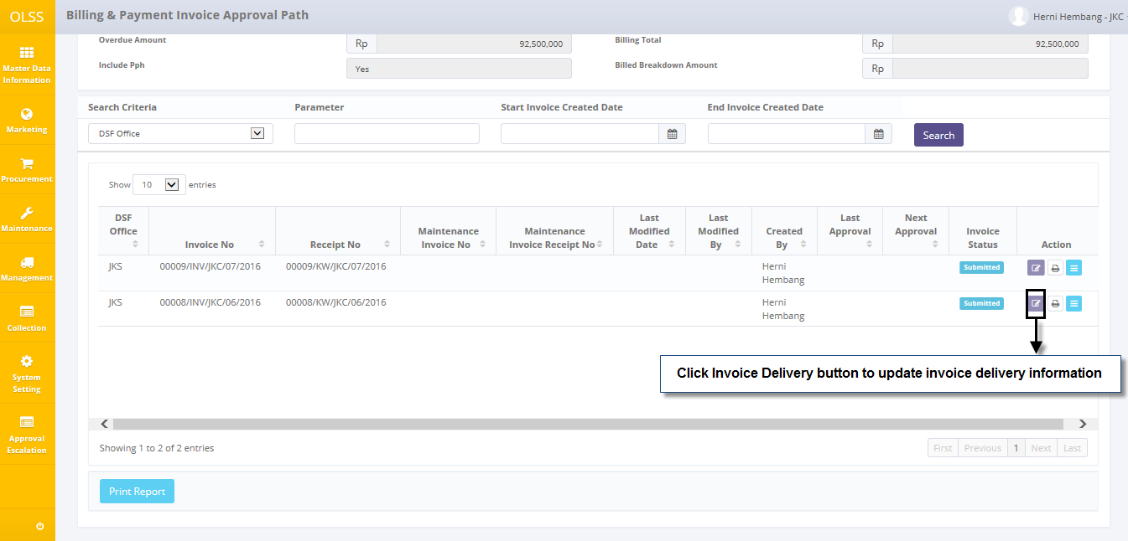

Screen 27: Billing & Payment Invoice Approval Path Screen – Invoice Delivery Button

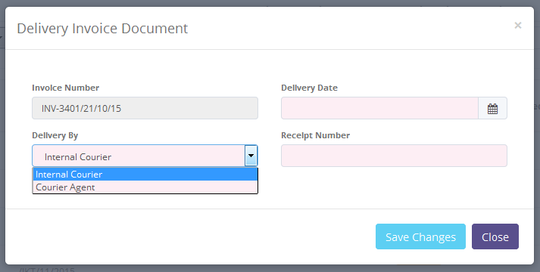

Screen 28: Delivery Invoice Document Pop Up Screen

Then fill the mandatory fields. If the **delivery by** is by Courier Agent, user has to input **Receipt Number**. Click  or  button to go back to **Billing & Payment Invoice Approval Path** screen. Success notification will show on top of the screen. Then invoice status will change to.

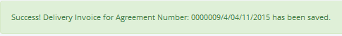

Screen 29: Invoice Delivery Success Notification

### Invoice Approval

DSF authorized user can use this feature to check, revise, or approve the invoice before the invoice hardcopy is sent to customer. Invoice approval path is static from PIC collection – HOB/HOD. First, access the screen by clicking Detail Invoice button.

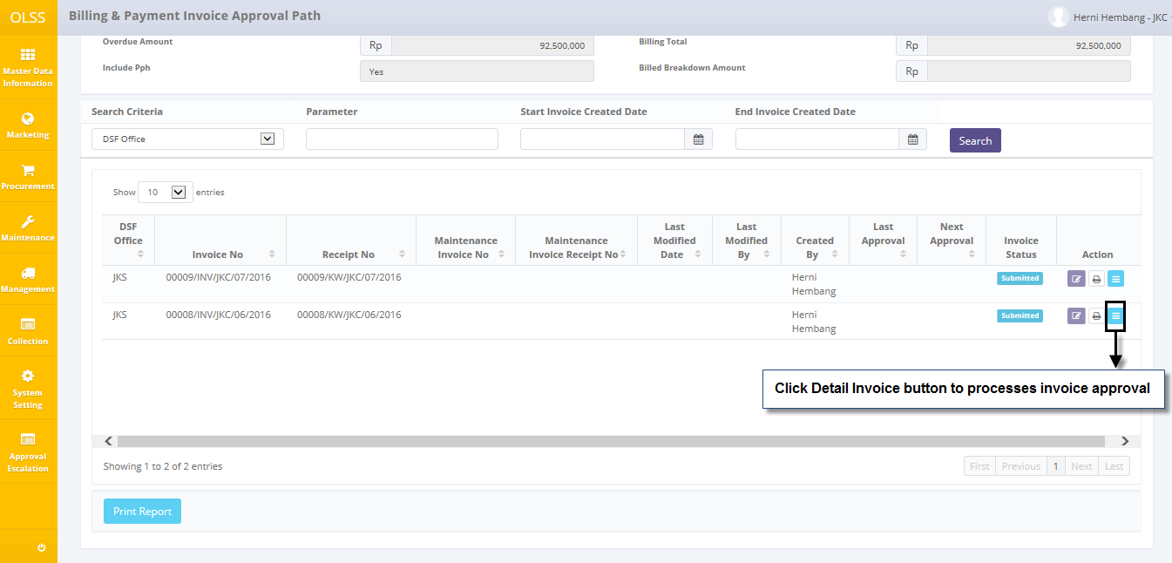

Screen 30: Billing & Payment Invoice Approval Path – Detail Invoice Button

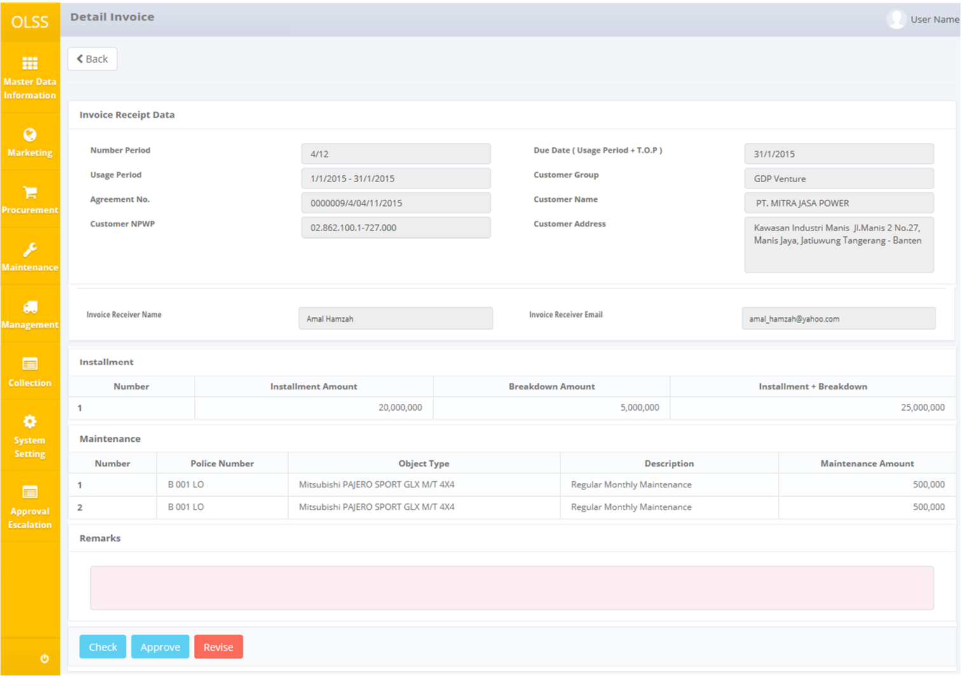

Screen 31: Invoice Approval Screen

Input remarks with reason, and then click check, revise, or approve the invoice. Screen will change back to **Billing & Payment Invoice Approval Path** screen and invoice status will change according the button clicked. After the invoice is approved, the invoice can be sent to customer.

### Print Invoice Form

To print Invoice form, user can access the feature from Billing & Payment Invoice Approval Path screen, and then click on Print button on selected invoice.

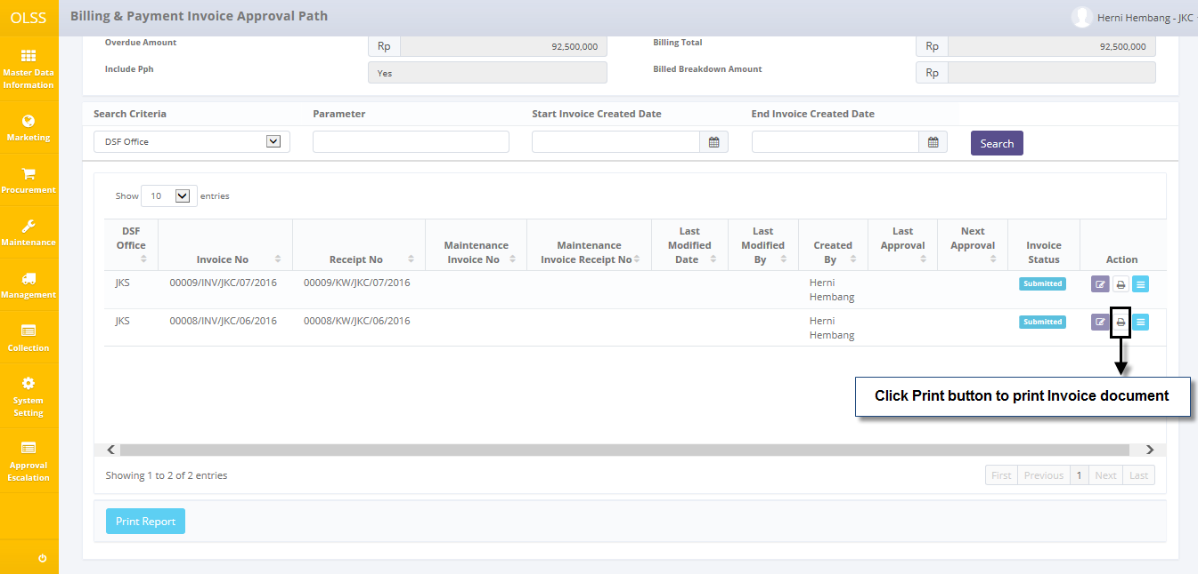

Screen 32: Billing & Payment Approval Path – Print button

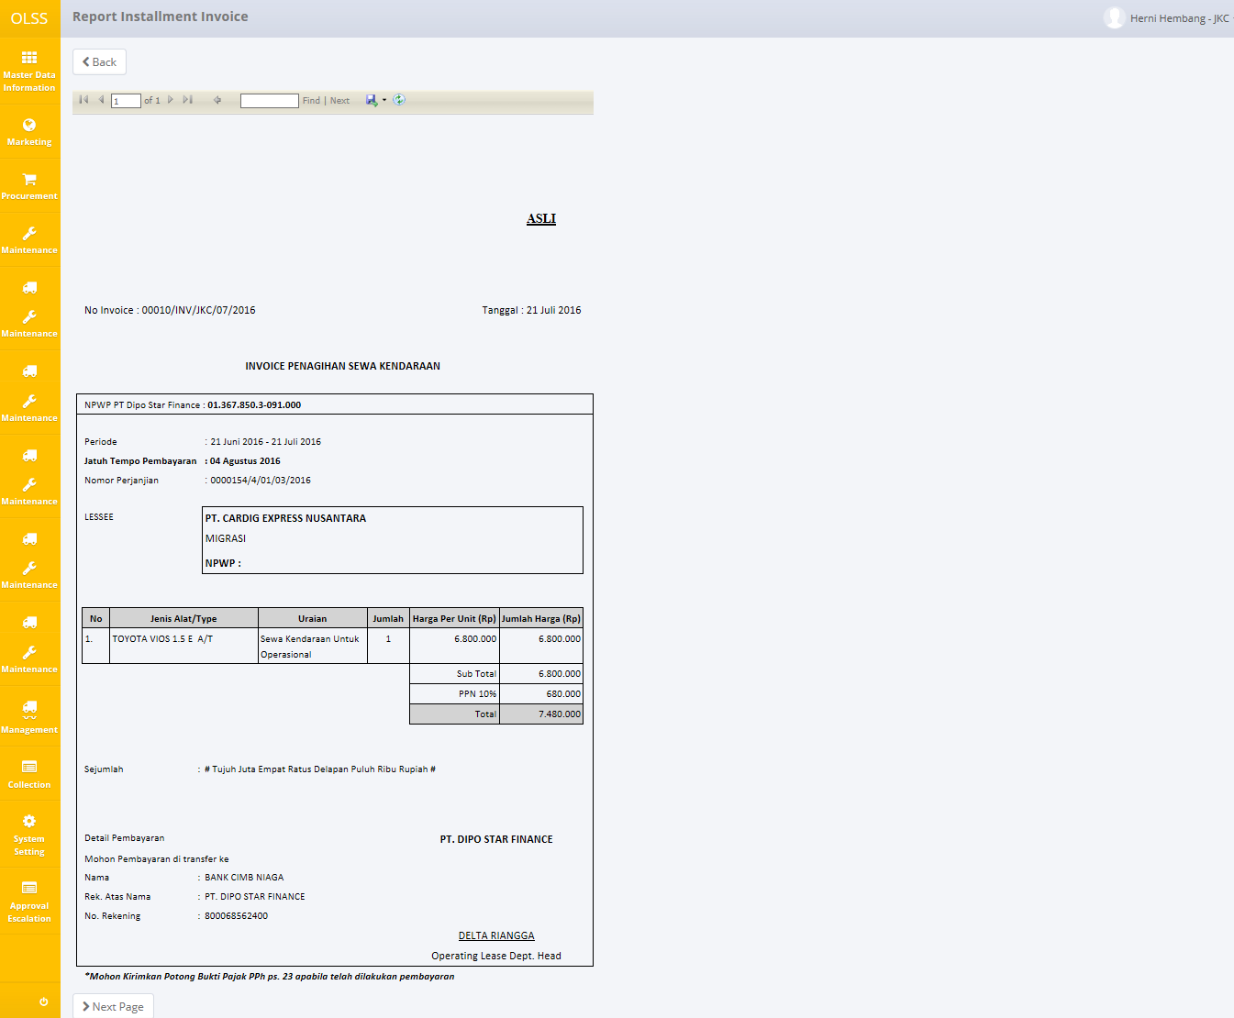

Screen 33: Invoice Print Preview

When you print Invoice form system also print Receipt and Receive Letter.

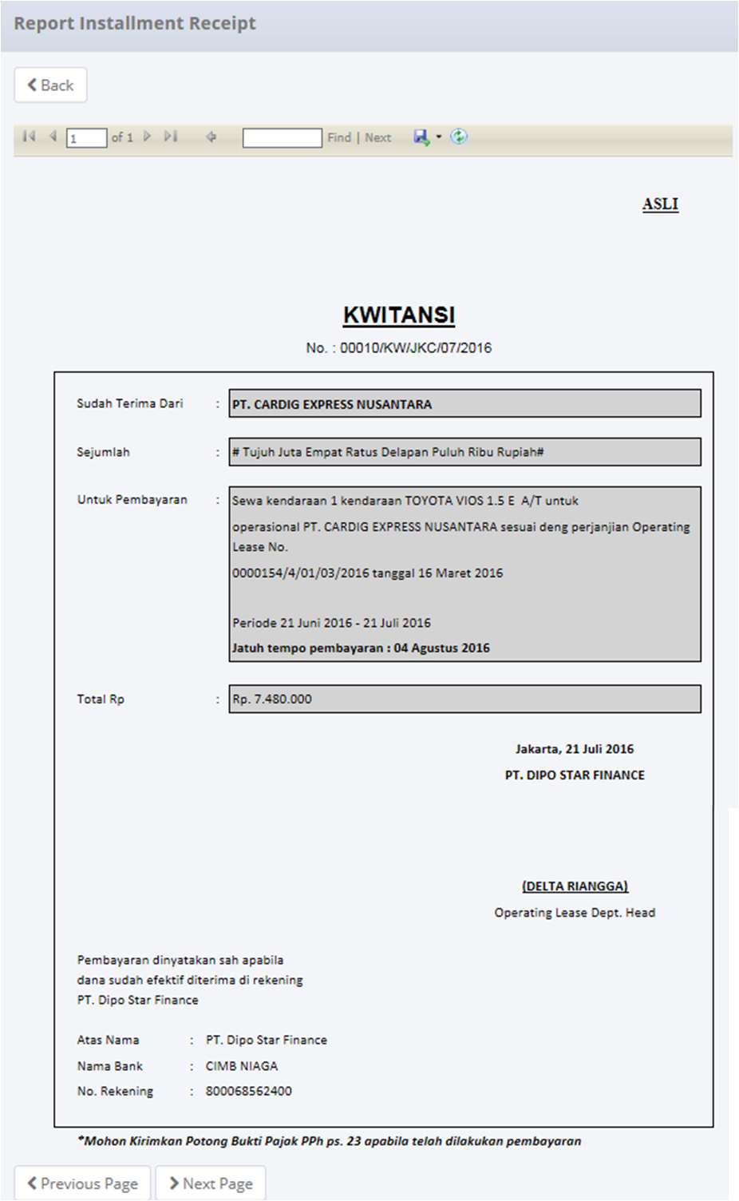

Screen 34: Receipt Print Preview

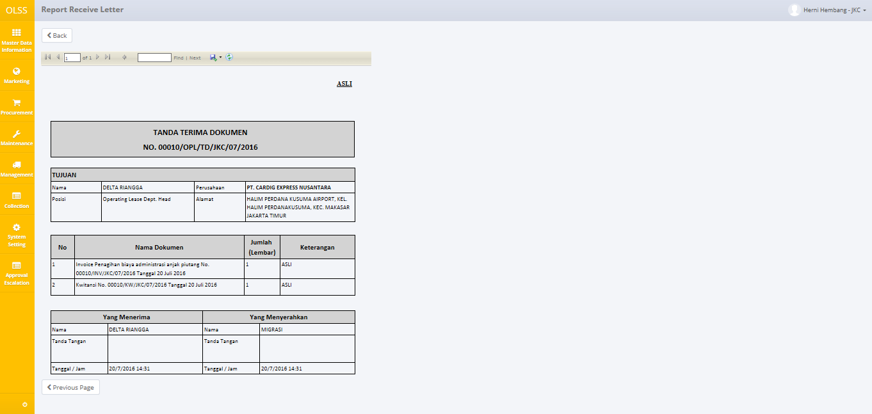

Gambar 35: Print Preview Kwitansi

User can choose to print the Invoice form, or save document as Excel or PDF.

### Print List of Invoice Report

To print Invoice List report, user can access the feature from **Billing & Payment Invoice Approval Path** screen, click on Print Report button on the bottom of the screen.

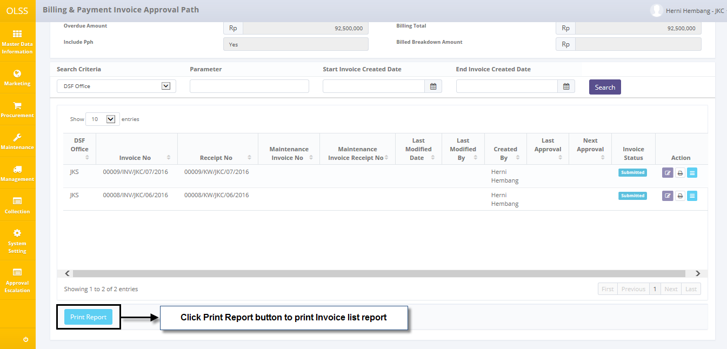

Screen 36: Billing & Payment Invoice Approval Path Screen - Print Report Button

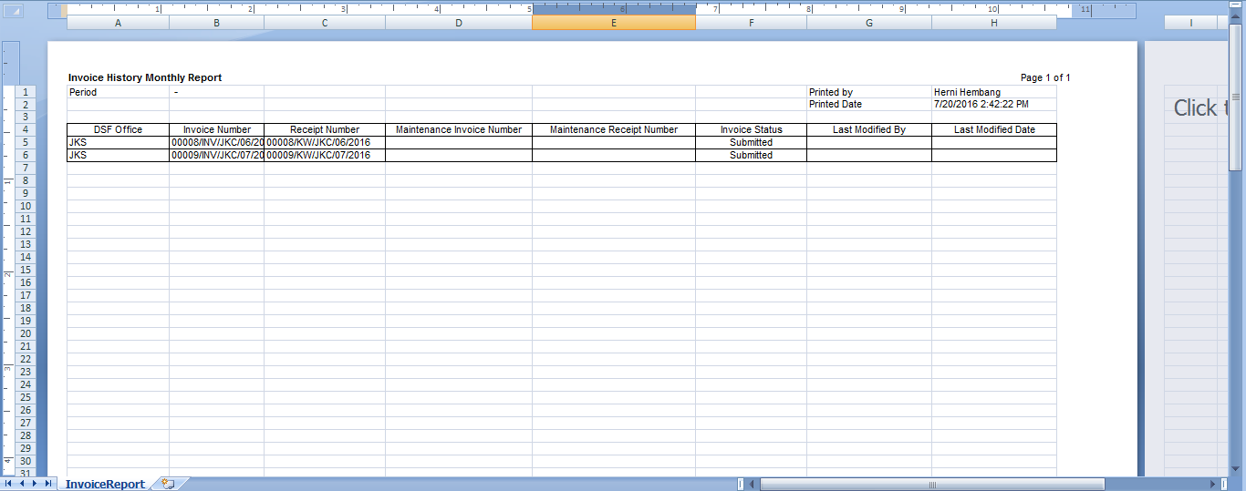

Gambar 37: Invoice History Monthly Report

User can choose to print the List of Invoice Report, or save document as Excel.

## View Billing and Payment History Inquiry

This feature will give user a view for contract information, billing and payment history, insert new partial payment, and edit billing and payment. To use this feature, simply navigate to tab 5 days or tab 1 day. Then click **Billing and Payment History Inquiry** button.

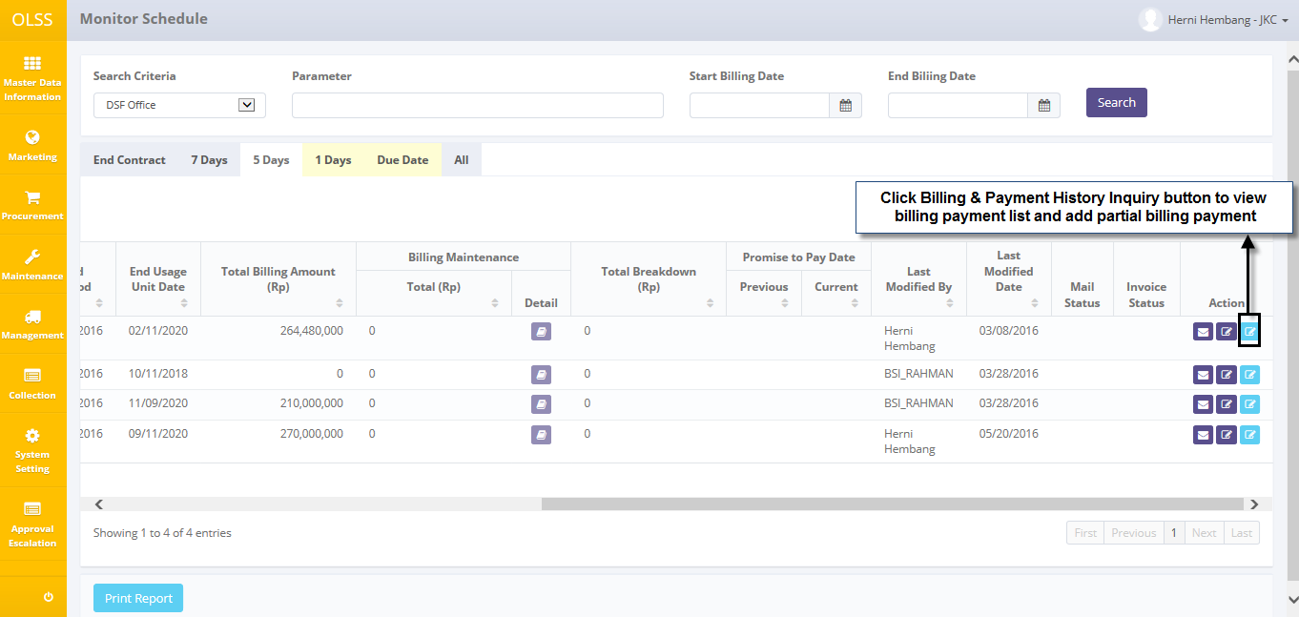

Screen 38: Monitor Billing Schedule Screen – Tab 5 Days

System will navigate to Billing and Payment History Inquiry screen.

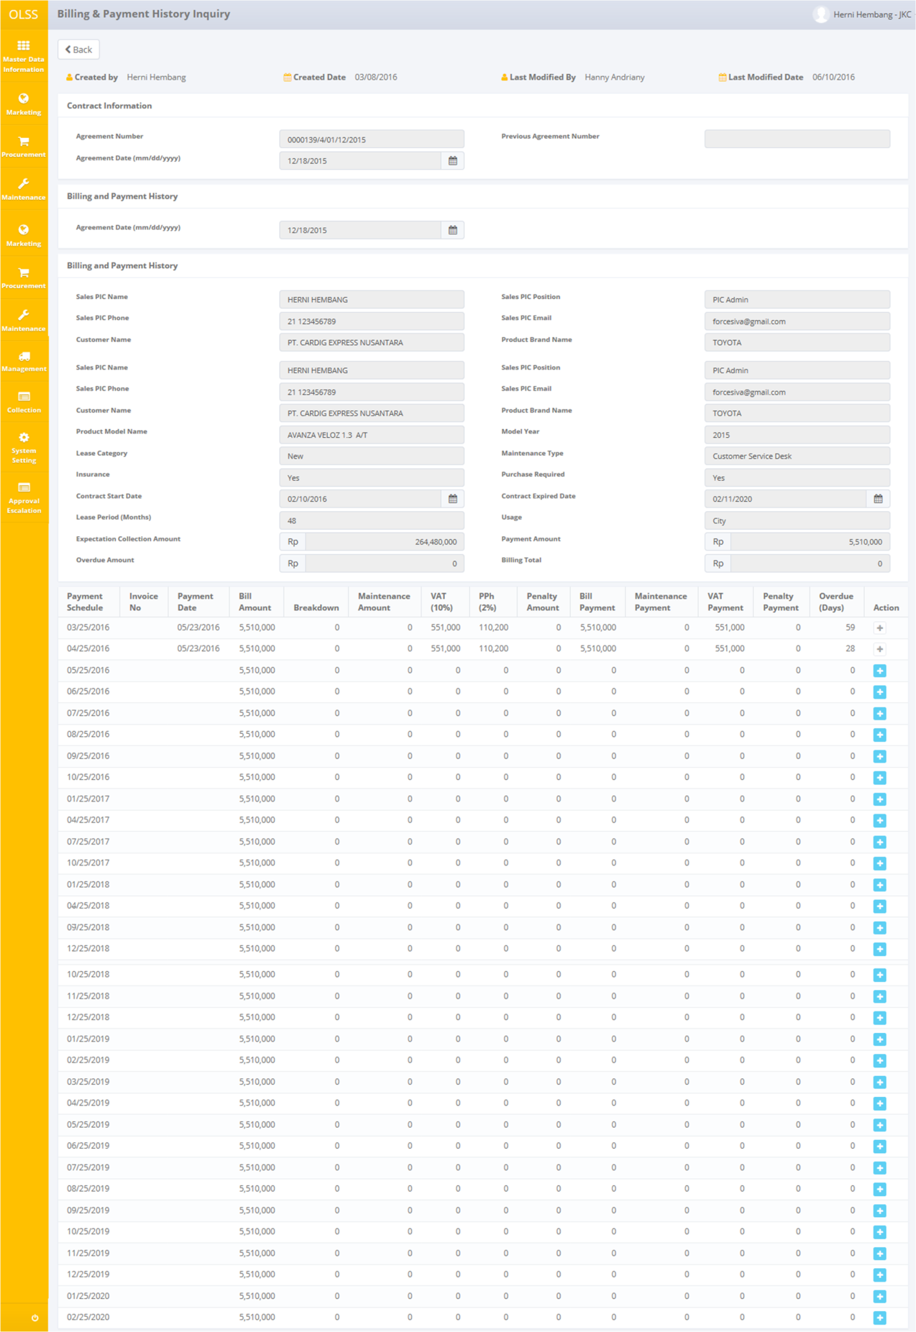

Screen 39: Billing & Payment History Inquiry Screen

There are total 2 buttons displayed.

* 1. : To go back to previous screen; Monitor Schedule screen.



* 1. Add Partial Billing Payment: to update billing payment list.

There are payment schedule on the bottom of the screen. Each row is generated each month. User only has to change the information if the customer has paid the billing payment.

### Add Billing Payment History Inquiry

If the user request to conduct billing payment not in full payment, user can input the remaining payment using this feature. First click Add button near the bottom of the screen.

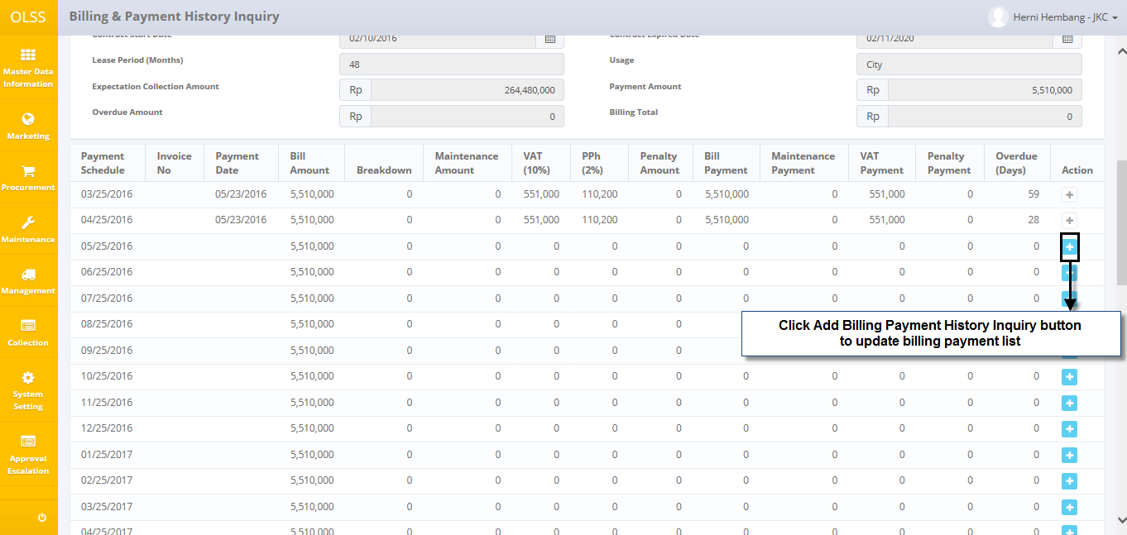

Screen 40: Billing & Payment History Inquiry – Add Billing Payment History Inquiry button

System will navigate to Billing and Payment History Detail screen.

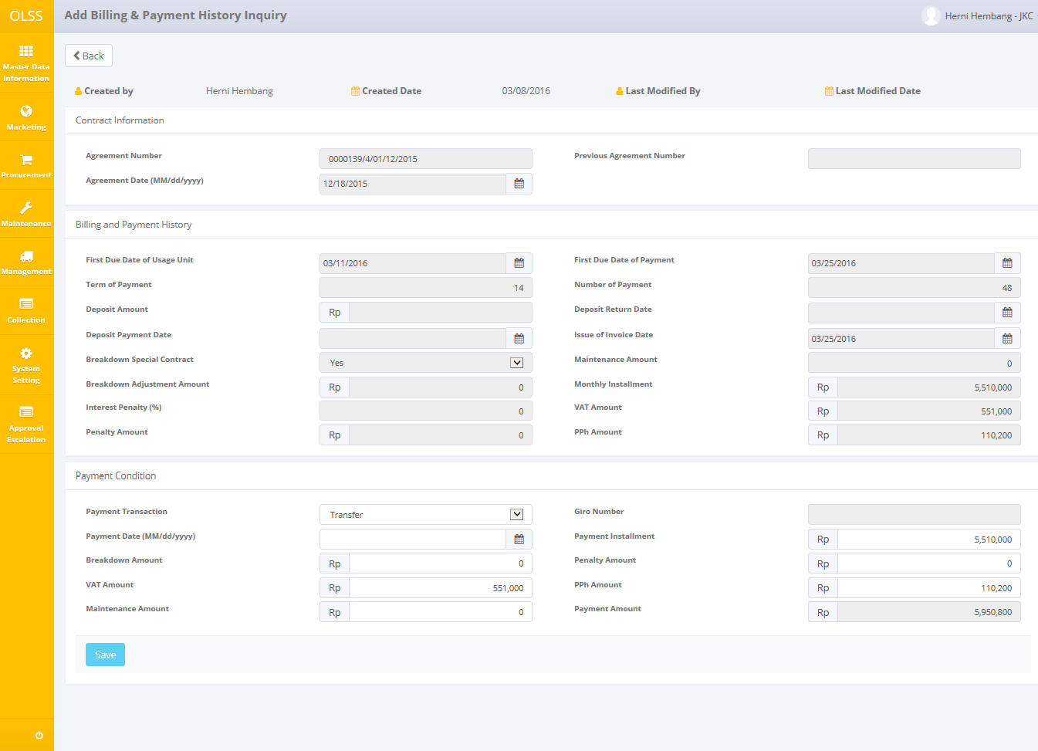

Screen 41: Add Billing & Payment History Inquiry Screen

Next, please fill information on the following fields:

* 1. Payment transaction: select transaction way, by transfer or giro.
  2. Payment date (mm/dd/yyyy): input payment date.
  3. Breakdown amount: input amount breakdown.
  4. VAT amount: input amount tax.
  5. Maintenance amount: input amount maintenance.
  6. Payment installment: input amount payment installment.
  7. Penalty amount: input amount if necessary.
  8. PPh amount: input amount income tax.

User can save data on the system by clicking Save button. System will go back to Billing & Payment History Inquiry screen and give success notification on top of the screen.



Screen 42: Billing and Payment History Detail Success Notification

## Create RAL

Return Authorization Letter is made after the customer contract had ended. To create RAL, there are two ways, first navigate to Monitor Billing Schedule screen – Tab End Contract. Click **Create RAL** button on the selected agreement.

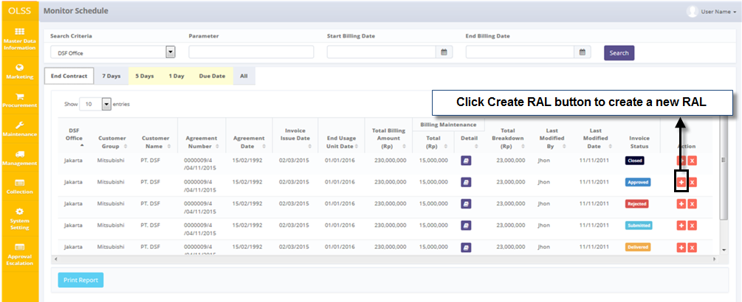

Screen 43: Monitor Billing Schedule – End Contract Tab

Or navigate to Monitor Overdue, and click Create RAL button.

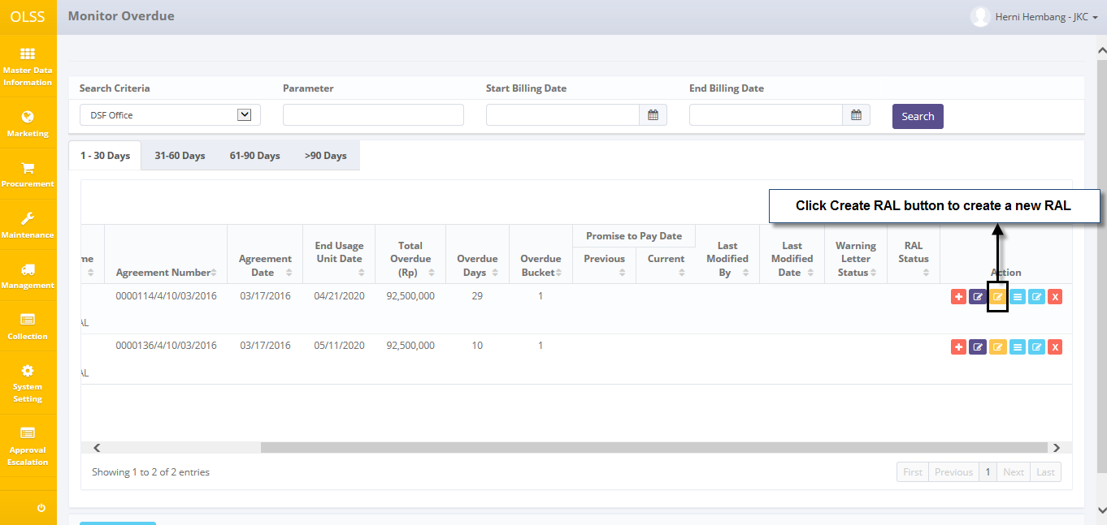

Screen 44: Monitor Overdue Screen – RAL button

System will display **Create RAL** screen.

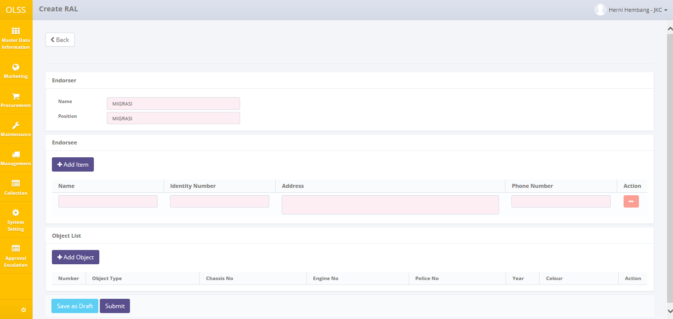

Screen 45: Create RAL Screen

Fill information on the fields as follow:

1. Endorser

* Name: input endorser name.
* Position: input endorser work position.

1. Endorsee

* Name: input endorsee name.
* Identity Number: input endorsee identity number.
* Address: input endorsee address.
* Phone number: input endorsee phone number.
* Delete button: to delete row of endorsee.
* 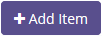: click to add more endorsee.

1. Object List

* Click 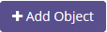 button to add more unit. System will display Object List pop up screen. Click Object Type to input more units.

User can save data on the system by clicking Save as Draft or Submit. Saved RAL can be managed in Monitor Overdue Screen. Saving RAL as draft will change RAL status into Draft, and submit RAL will change RAL status into Submitted. Clicking Save or Submit button will display confirmation pop-up dialog will show up. Click yes to continue. System will automatically go back to **Monitor Schedule** screen and success notification will show on top of the screen.

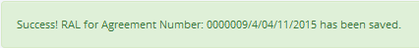

Screen 46: Create RAL Success Notification

# Monitor Billing Overdue

Monitor Billing Overdue screen featured monitoring overdue agreement, manage RAL, and manage warning letter. Overdue means agreement current date is more than agreement due date, and also customer hasn’t conduct payment yet. To get to Monitor Billing Overdue screen, please navigate to Collection Menu, and choose Monitor Billing Overdue.

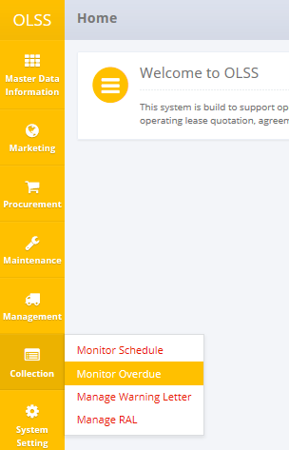

Screen 47: Collection Menu – Monitor Overdue

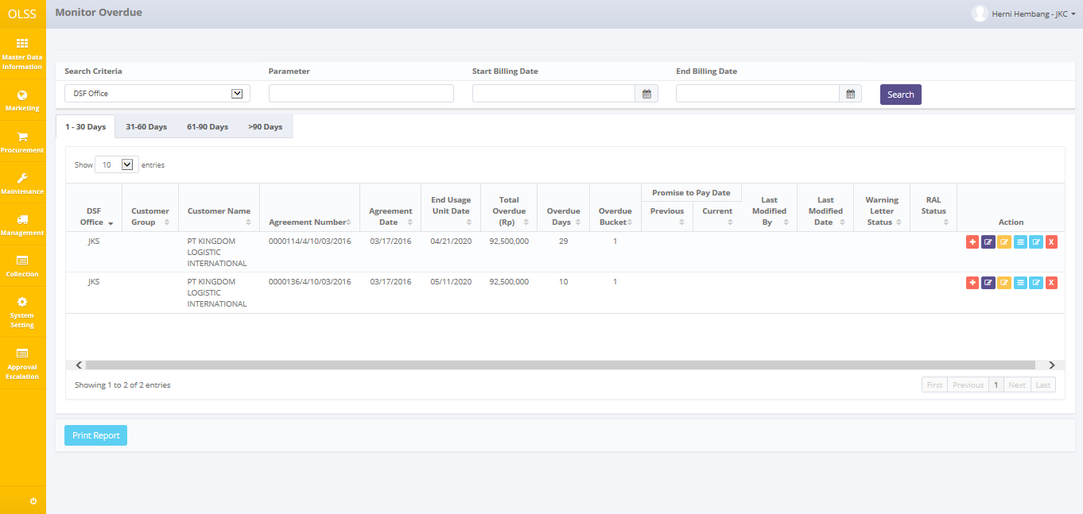

Screen 48: Monitor Overdue Screen

On the screen of Monitor Overdue, there are 4 tabs:

1. 1-30 days: display billing data with overdue from 1 – 30 days.
2. 31-60 days: display billing data with overdue from 31 - 60 days.
3. 61-90 days: display billing data with overdue from 61 – 90 days.
4. > 90 days: display billing data with overdue more than 90 days.

On the screen of Monitor Overdue, there are 7 buttons:

1. Create Reminder Memo: Update reminder information for selected agreement.
2. Create warning letter: create warning letter for selected agreement.
3. Create RAL: create RAL for selected agreement. (this process is similar to the one that has been explained on Monitor Schedule screen)
4. Reminder memo history: view reminder memo history for selected agreement.
5. Billing & Payment History Inquiry: view billing payment information, can navigate to Add Partial Billing Payment screen. (this process is similar to the one that has been explained on Monitor Schedule screen)
6. Stop Billing  : Change contract status from OPEN to STOP BILLING. Agreements with status STOP BILLING cannot be changed or do any action (all buttons are disabled). (this process is similar to the one that has been explained on Monitor Schedule screen)
7. 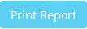: Print Overdue billing list for specific search.

## Create Reminder Memo

User can input update after reminding customer for monthly payment by utilizing **Reminder Memo** feature. If user wants to use function **Reminder Memo**, please follow procedures shown below:

1. Click **Reminder Memo** button on selected agreement (first button on the action column) on **Monitor Billing Overdue** screen.

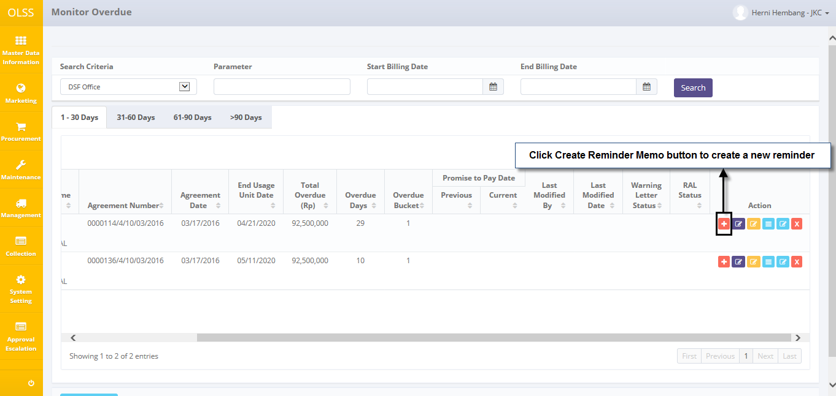

Screen 49: Monitor Overdue – Reminder Memo Button

1. System will display Reminder Memo pop up screen.

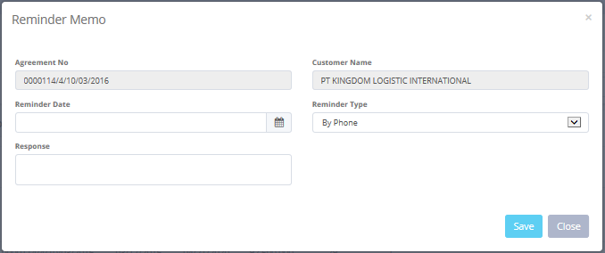

Screen 50: Reminder Memo Screen

Fill fields with necessary information as follows:

* Agreement No: automatically display selected agreement number.
* Customer Name: automatically display selected customer name.
* Reminder Date: input reminder date.
* Reminder Type: input type By Phone or By Visit (to customer).
* Response: input customer response.

User can save data on the system by clicking Save. Any new information will be recorded in **Reminder Memo History** (Monitor Overdue – Reminder Memo History button). Clicking Save button will display confirmation pop-up dialog will show up. Click yes to continue. System will automatically go back to **Monitor Overdue** screen.

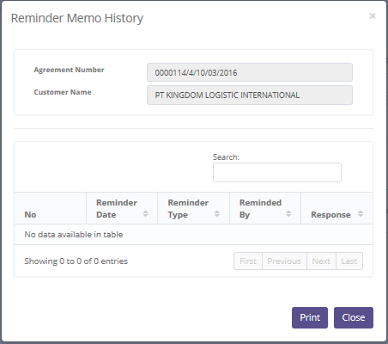

Screen 51: Reminder Memo History Screen

## Create Warning Letter

If the agreement has reached past the due date and customer hasn’t conducted the payment, then user can create Warning Letter for selected agreement. To create Warning Letter, click Create Warning Letter button on the selected agreement.

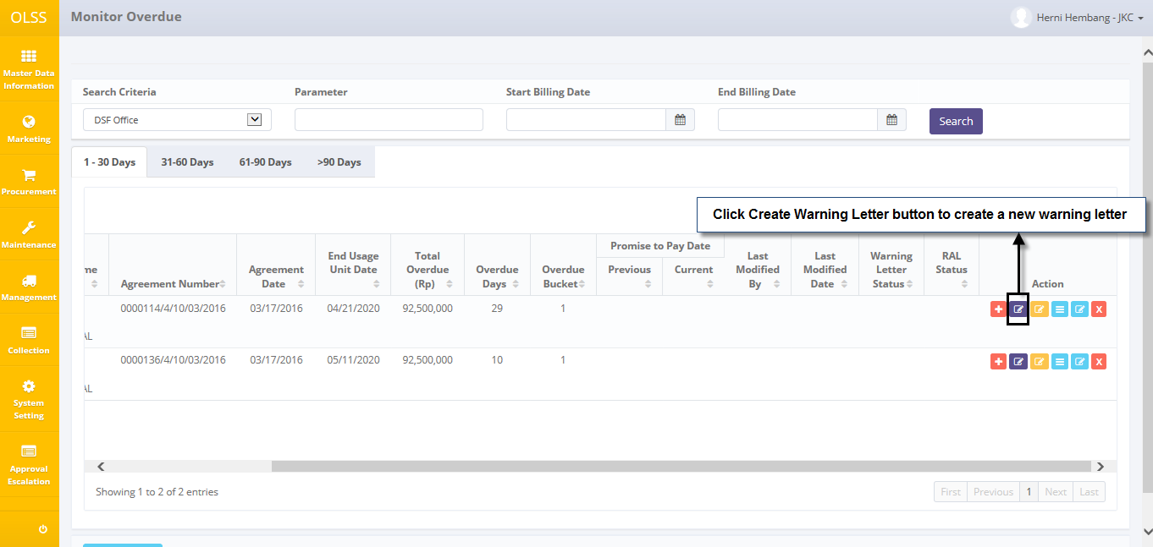

Screen 52: Monitor Overdue – Warning Letter Button

System will display Create Warning Letter screen.

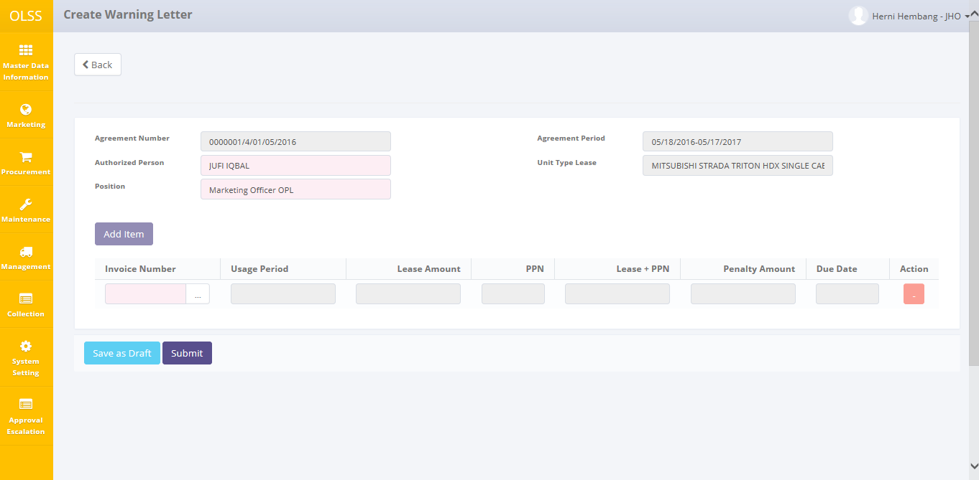

Screen 53: Create Warning Letter Screen

Fill information as follows:

* Authorized Person: input authorized user who make the warning letter.
* Position: input authorized person job position.
* Select Invoice Number to be issued. Click add item button to make Warning Letter for more than one invoice number at once.

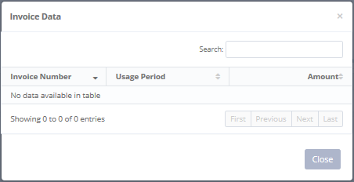

Screen 54: Invoice List in Create Warning Letter Screen

User can save data on the system by clicking Save as Draft or Submit button. Saved Warning Letter can be managed in Monitor Overdue Screen. Saving Warning Letter as draft will change Warning Letter status into Draft, and submit Warning Letter will change Warning Letter status into Submitted. Clicking Save button will display confirmation pop-up dialog will show up. Click yes to continue. System will automatically go back to **Monitor Overdue** screen. System will display success notification on top of the screen.

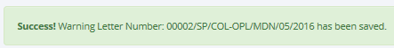

Screen 55: Warning Letter Success Notification

# Print Billing (schedule/overdue) History

On the bottom screen of Monitor Billing Schedule and Monitor Billing Overdue screen, there is a button for Print Report. User can use the feature to print the Billing Schedule History report and Monitor Billing Overdue screen.

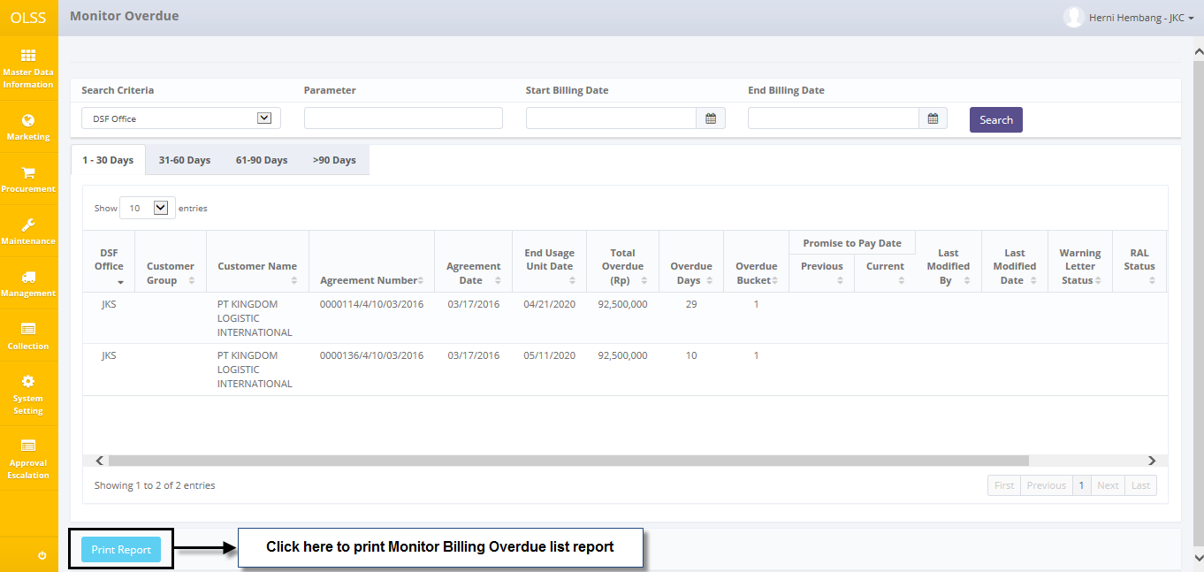

Screen 56: Print report for monitor billing overdue

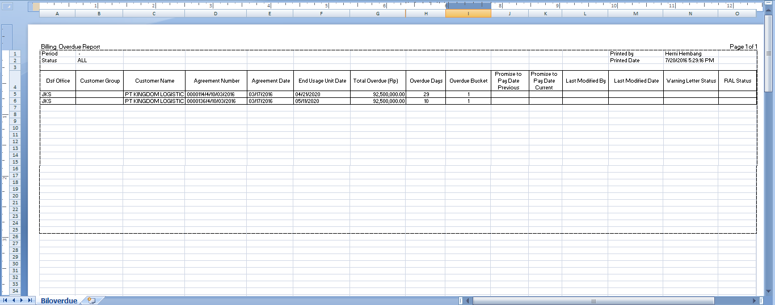

Screen 57: Billing Overdue Report

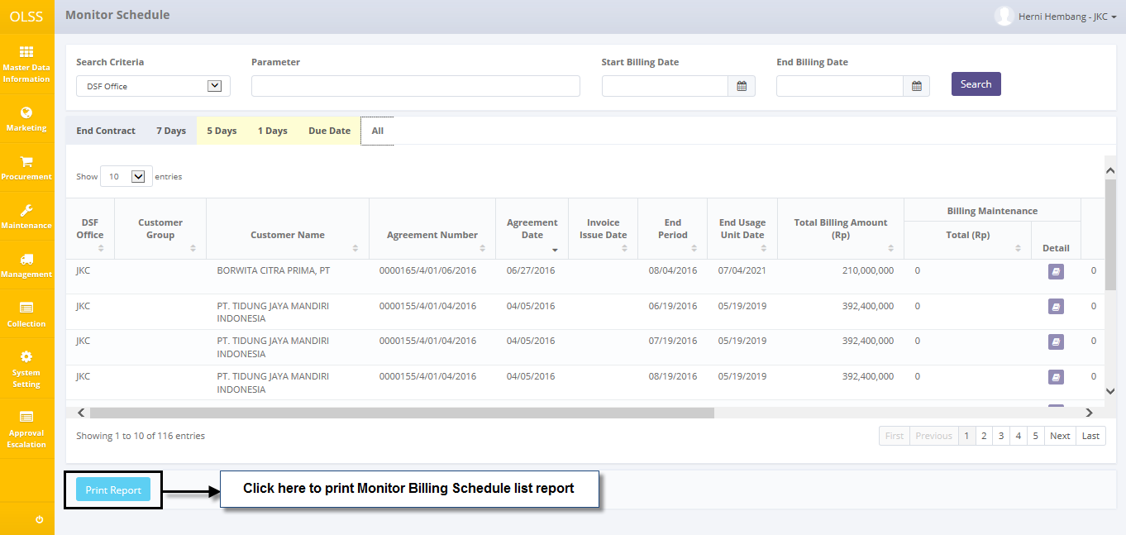

Screen 58: Print report for monitor billing schedule

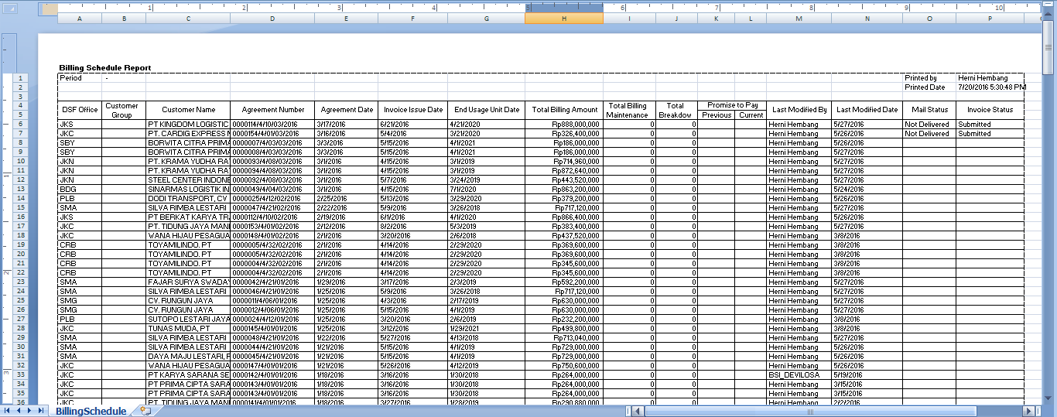

Screen 59: Billing Schedule Report

After clicking the button, system will navigate to Billing report print preview. User can print document as hardcopy, or save document as Ms. Excel.

# Manage Warning Letter

To edit warning letter, user can navigate to **List of Warning Letter** screen, by clicking **Manage Warning Letter** on menu below.

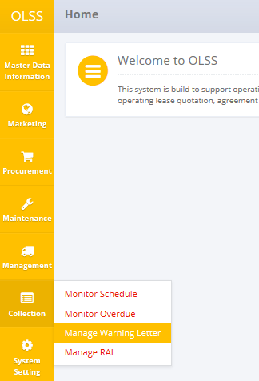

Screen 60: Collection Menu – Manage Warning Letter

System will navigate to List of Warning Letter screen. In here user can see warning letter created, overdue bucket and overdue days, total overdue, and warning letter status. Click Edit Warning Letter button on the selected Warning Letter document.

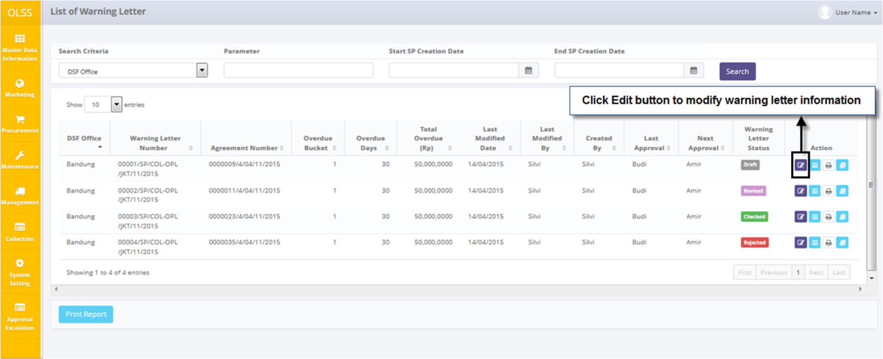

Screen 61: List of Warning Letter – Edit button

System will navigate to Edit Warning Letter screen.

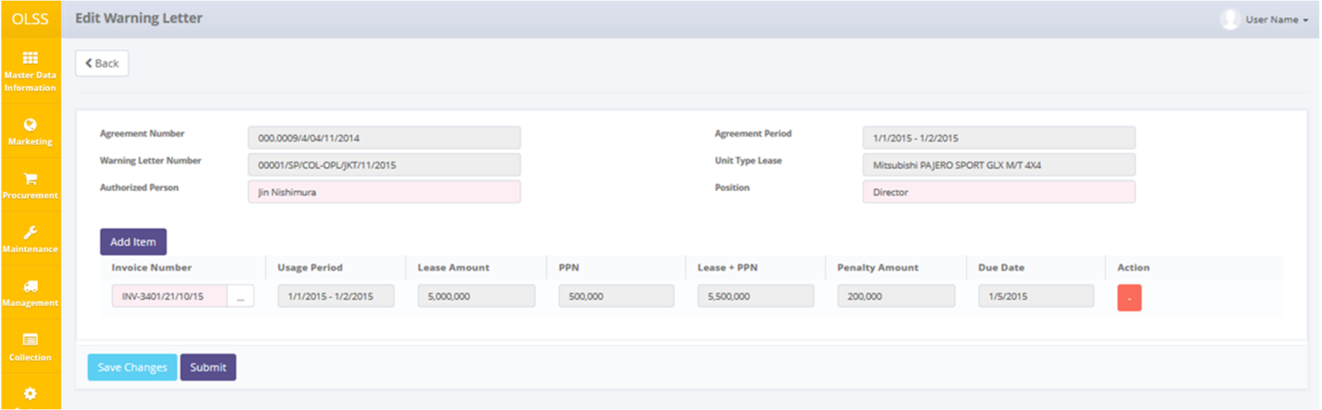

Screen 62: Edit Warning Letter Screen

If data already changed on the screen, user can save a data on the system by clicking **Save Changes** button or Submit. There are mandatory fields marked with red background field that should be inputted and it can’t leave as blanks. If you leave them blanks, system will notified it after you clicking **Save Changes or Submit** button. Make sure that you really want to submit the document, because Submitted document can no longer be modified. After clicking **Save Changes or Submit**, confirmation pop-up dialog will show up. Click yes to save document.

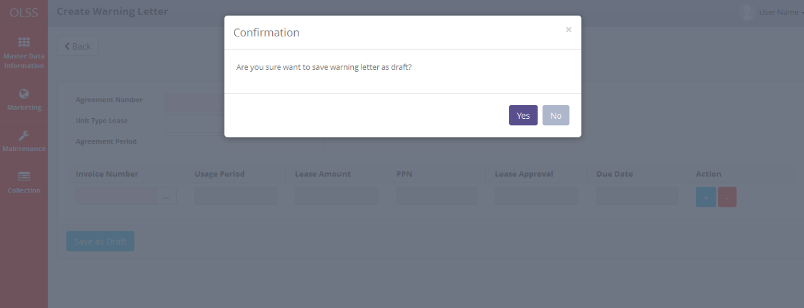

Screen 63: Save as Draft Confirmation Pop up

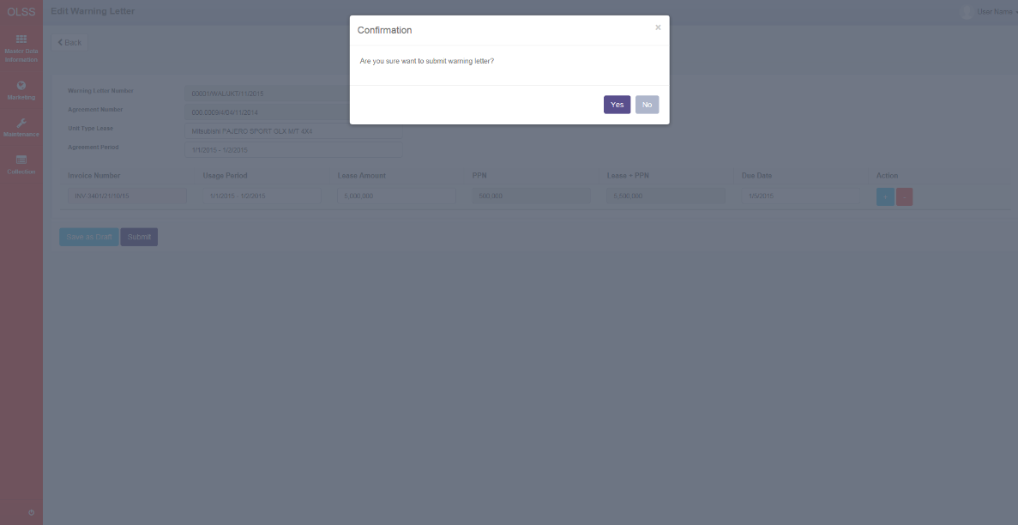

Screen 64: Submit Confirmation Pop up

System will notified if it success or failed to save changes.

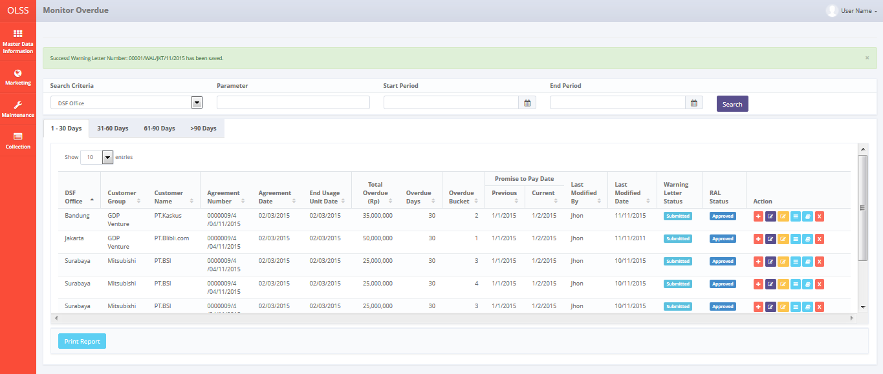

Screen 65: Success notification after Save as Draft

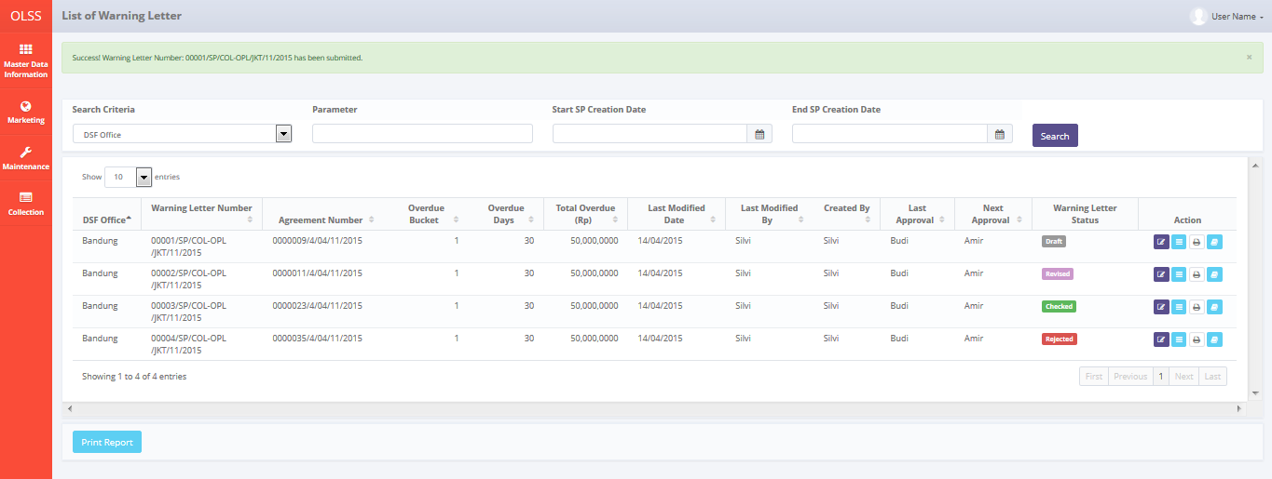

Screen 66: Success notification after setelah Submit

## Warning Letter Approval

DSF authorized user can use this feature to check, revise, reject, or approve the warning letter. First, access the screen by clicking Warning Letter approval button.

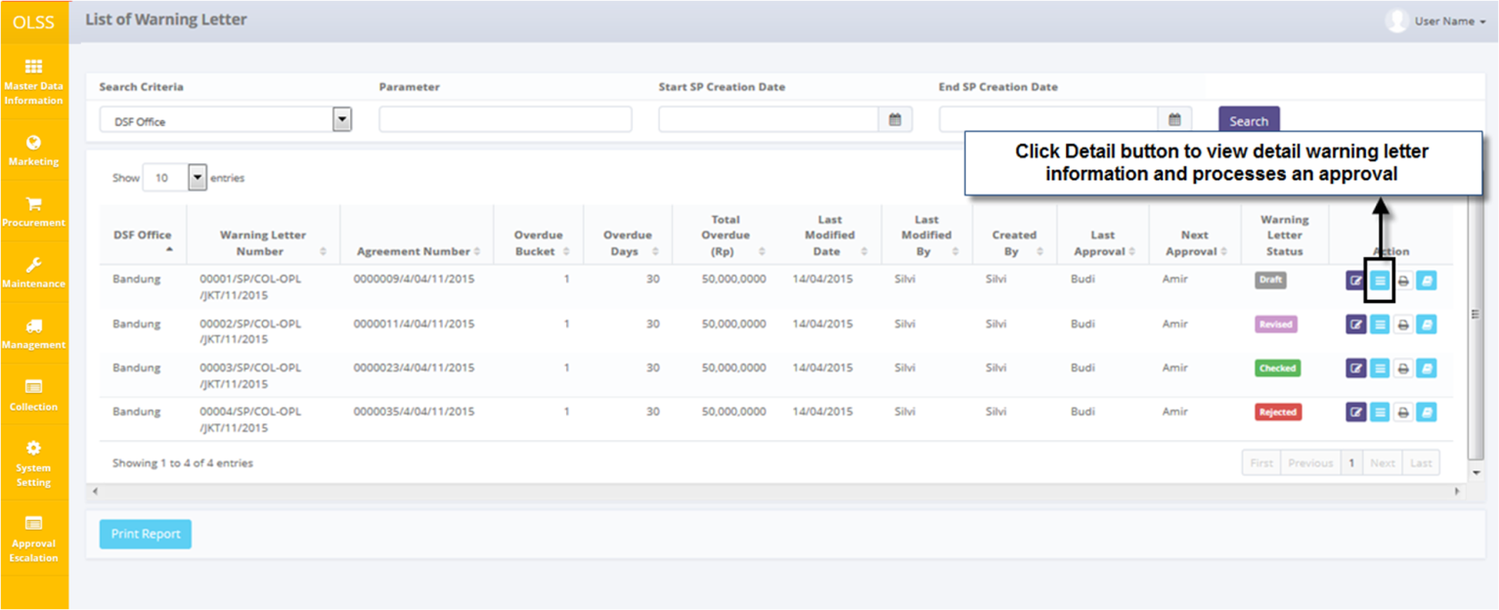

Screen 67: List of Warning Letter – Detail Button

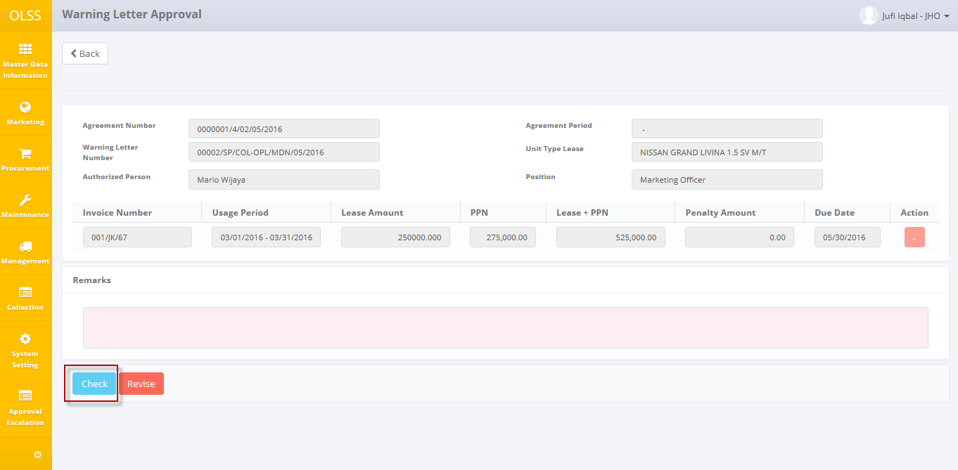

Screen 68: Warning Letter Approval Screen

Input Remarks with reason, and then click check, revise, or approve the invoice. Screen will change back to **List of Warning Letter** screen and Warning Letter status will change according the button clicked.

## Print Warning Letter Form

To print Warning Letter form, click Print button on selected Warning Letter.

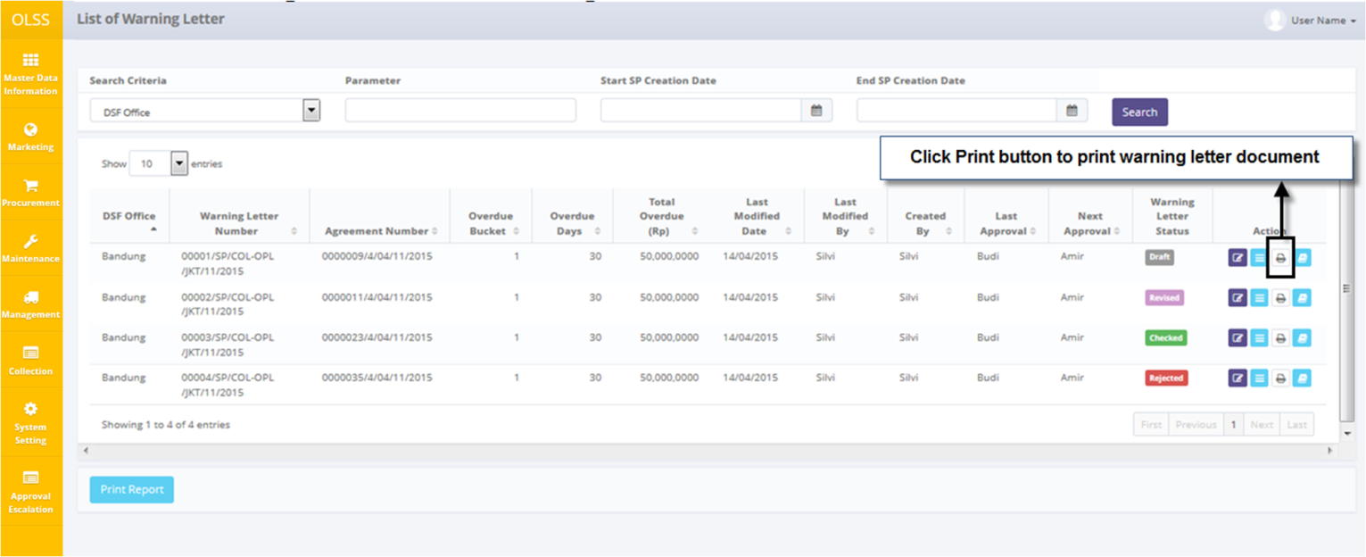

Screen 69: List of Warning Letter – Print Button

System will navigate to Warning Letter Form print preview.

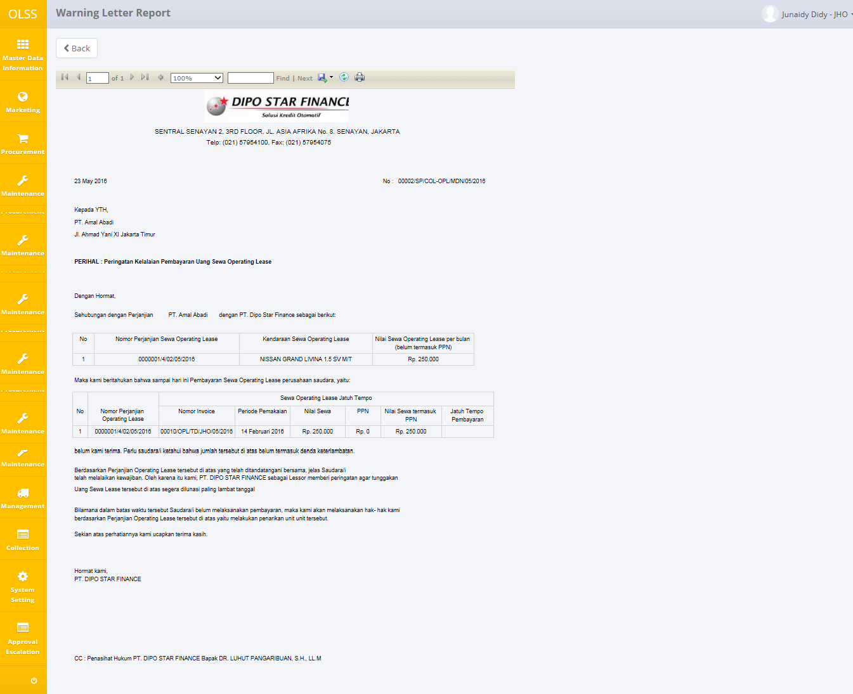

Screen 70: Warning Letter Form

User can choose to print the Warning Letter form, or save document as Excel or PDF.

## Warning Letter History

User can check the revision date of warning letter by navigating to Warning Letter history. Click Warning Letter History button on the selected Warning Letter number.

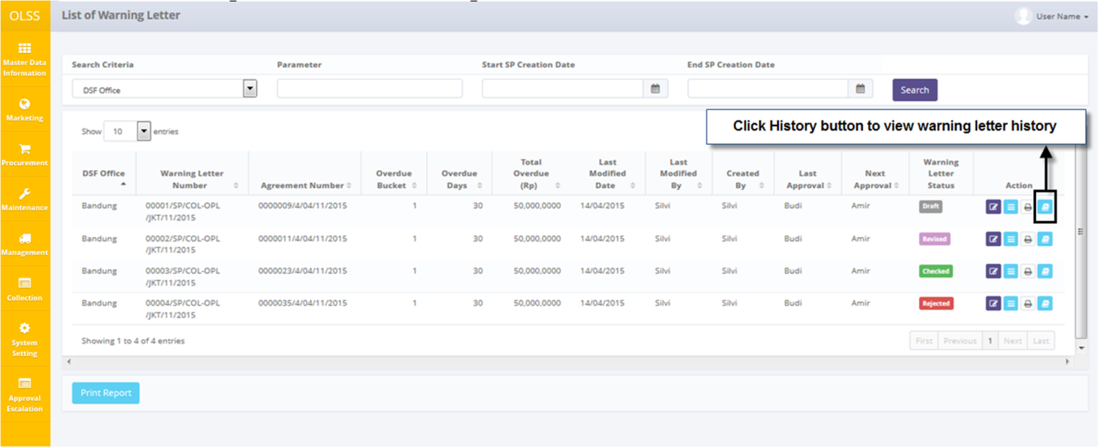

Screen 71: Warning Letter History Button

System will navigate to Warning Letter History screen.

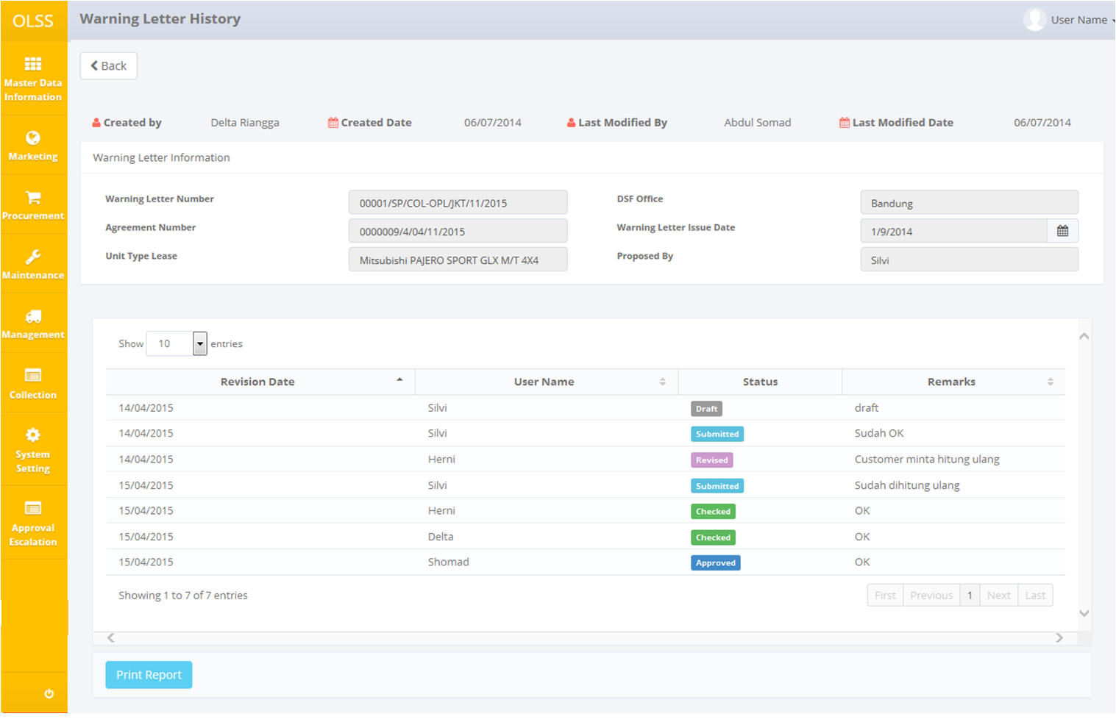

Screen 72: Warning Letter History Screen

## Print Warning Letter Report

To print warning letter report, user can access the feature from Warning Letter History screen, or from List of Warning Letter.

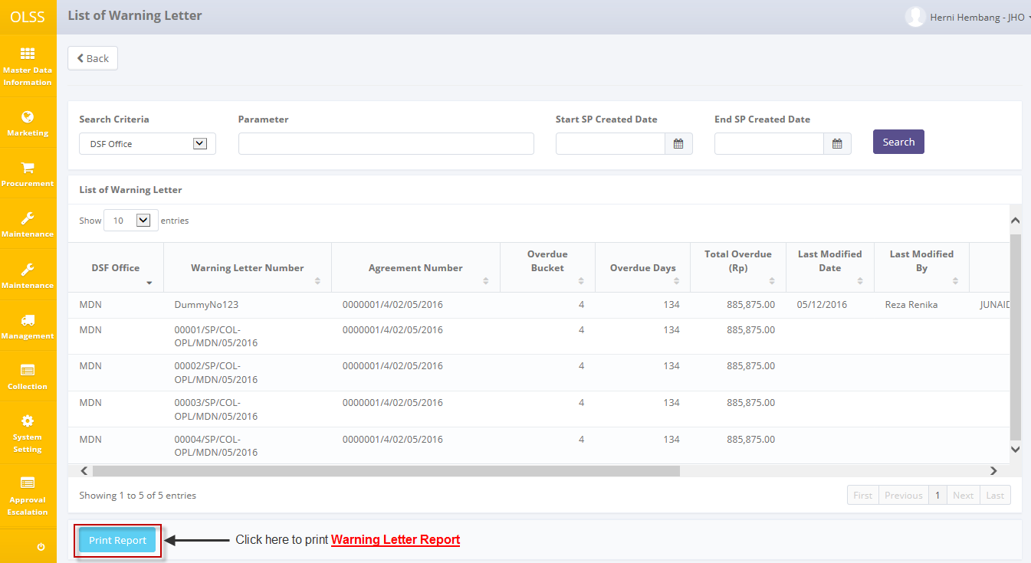

Screen 73: Alternative for Print Warning Letter History Report

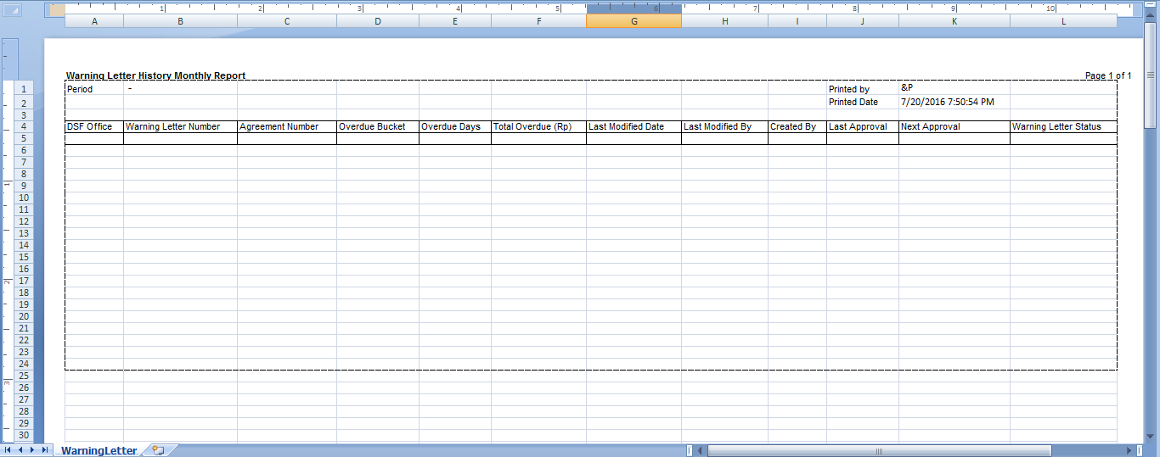

Screen 74: Warning Letter History Monthly Report

User can choose to print the Warning Letter form, or save document as Excel.

# Manage RAL

To edit RAL, user can navigate to **List of RAL** screen, by clicking Manage RAL on menu below

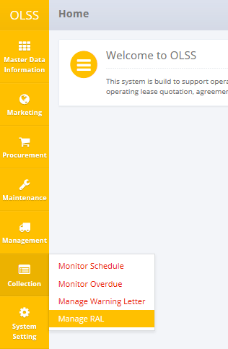

Screen 75: Collection Menu – Manage RAL

System will navigate to List of RAL screen. In here user can see RAL created, authorized person information, total unit, and RAL status. Click Edit RAL button on the selected RAL document.

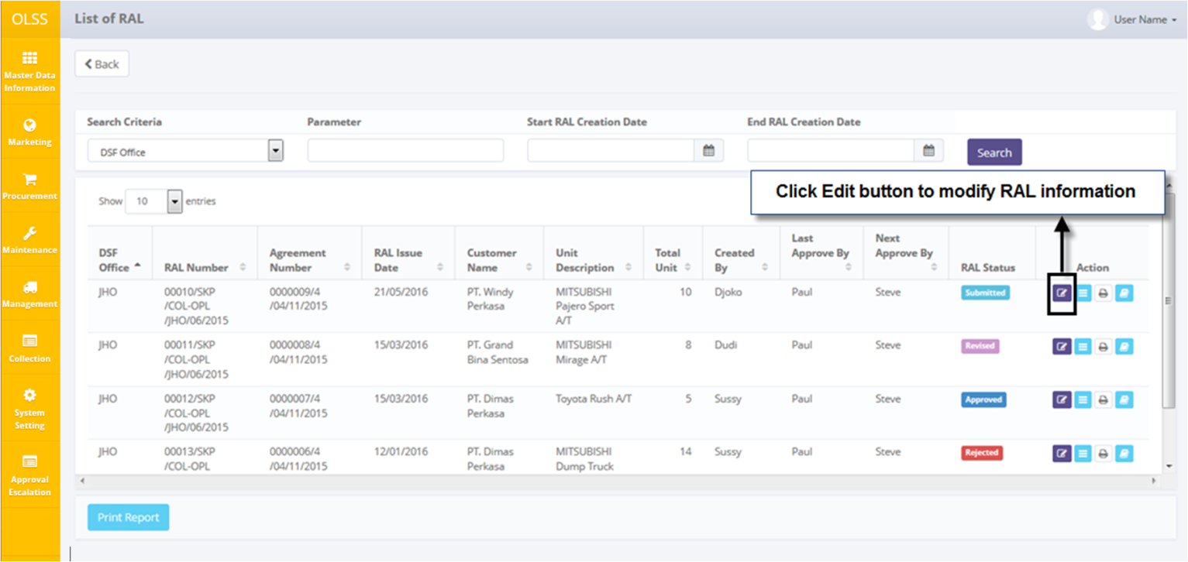

Screen 76: List of RAL screen – Edit button

System will navigate to Edit RAL screen. On the bottom of the screen, there is a Revision History fields consist of user information that has made changes to the document.

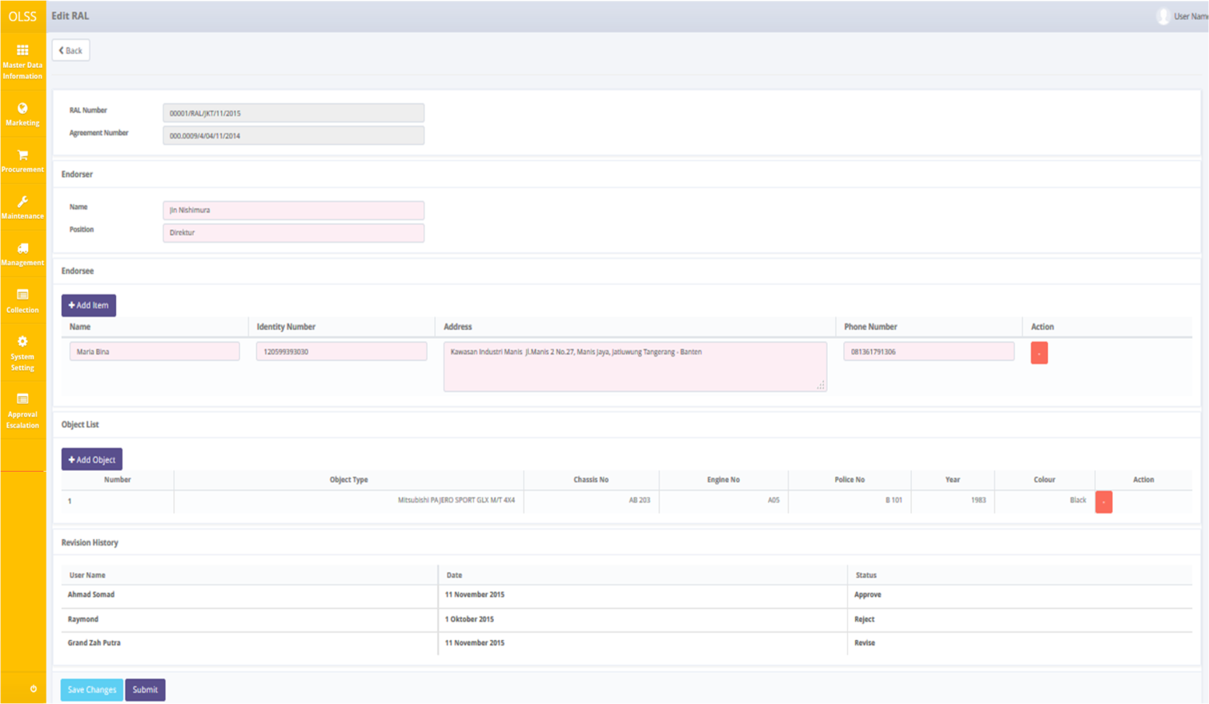

Screen 77: Edit RAL screen

If data already changed on the screen, user can save a data on the system by clicking **Save Changes** button or **Submit**. There are mandatory fields marked with red background field that should be inputted and it can’t leave as blanks. If you leave them blanks, system will notified it after you clicking **Save Changes** or **Submit** button. Make sure that you really want to submit the document, because Submitted document can no longer be modified. After clicking **Save Changes or Submit**, confirmation pop-up dialog will show up. Click yes to save document.

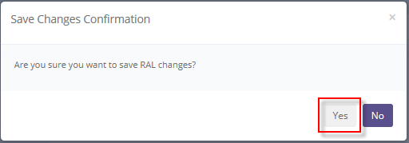

Screen 78: Edit RAL confirmation pop up screen

System will notified if it success or failed to save changes.

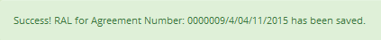

Screen 79: Edit RAL Success notification

## RAL Approval

DSF authorized user can use this feature to check, revise, reject, or approve the warning letter. First, access the screen by clicking RAL approval button.

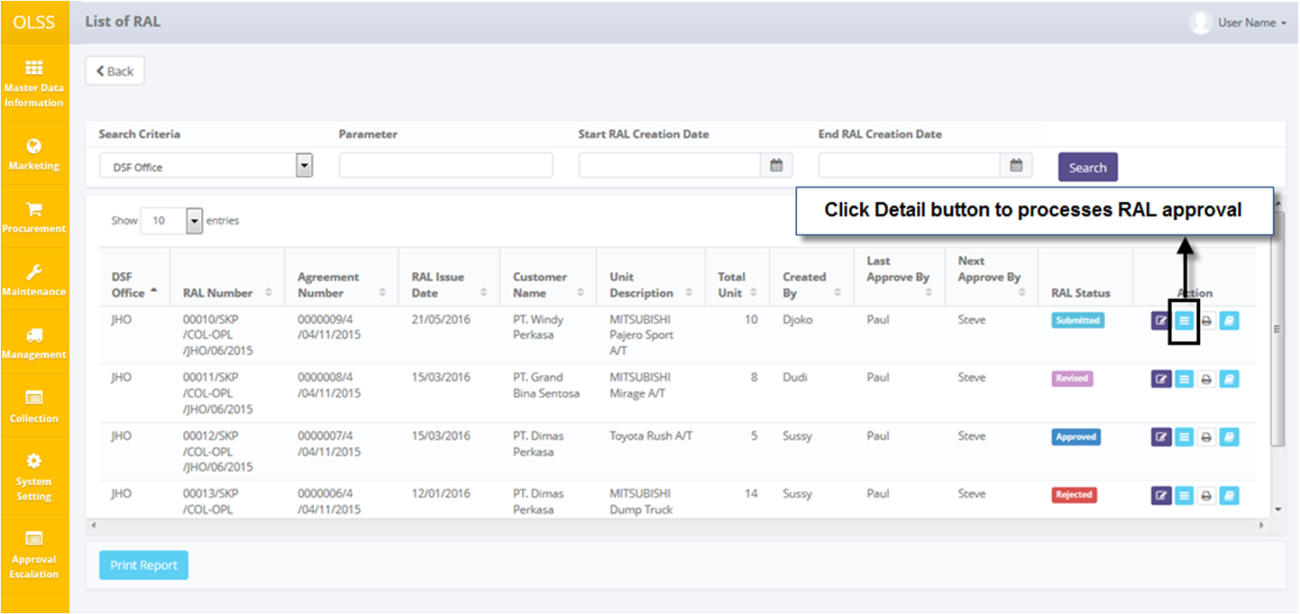

Screen 80: List of RAL – Detail button

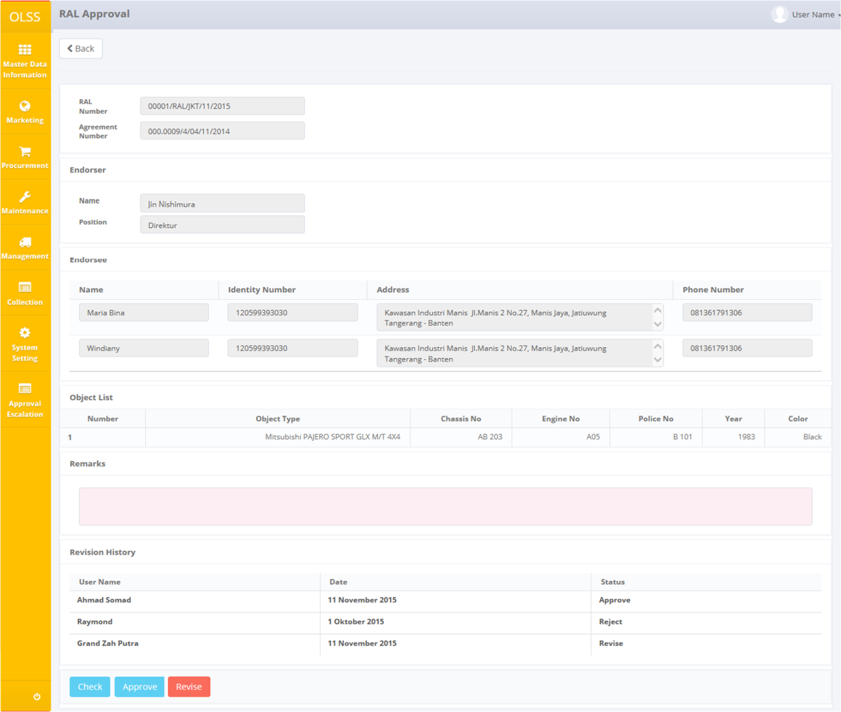

Screen 81: RAL approval screen

Input Remarks with reason, and then click check, revise or approve the RAL. Screen will change back to **List of RAL** screen and RAL status will change according the button clicked.

## Print RAL Form

To print RAL form, click **Print** button on selected RAL.

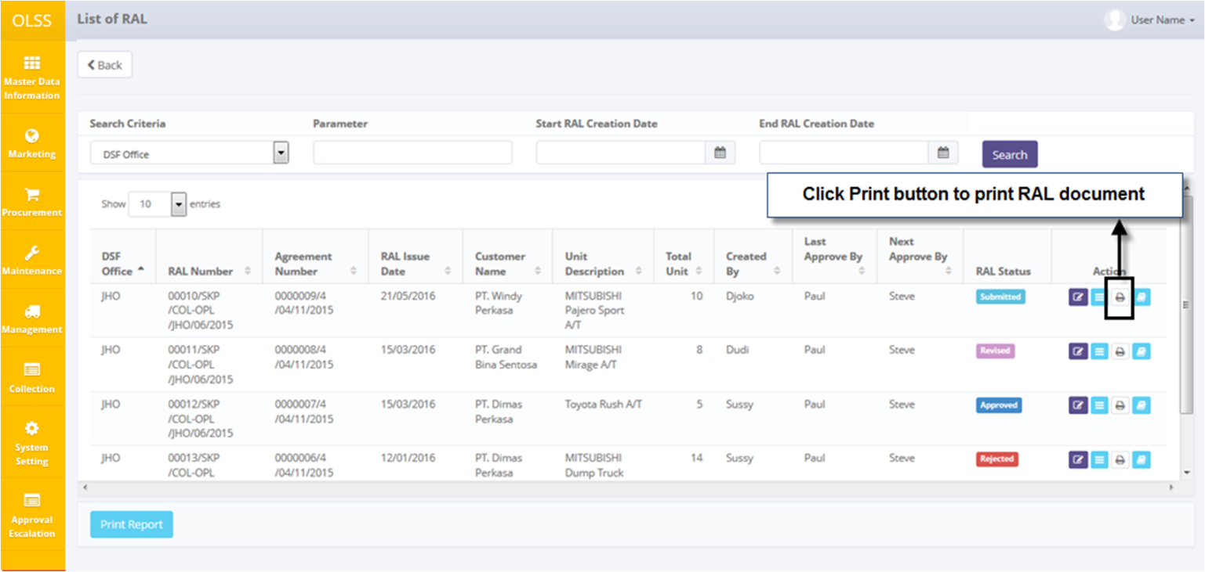

Screen 82: List of RAL – Print button

System will navigate to RAL Form print preview.

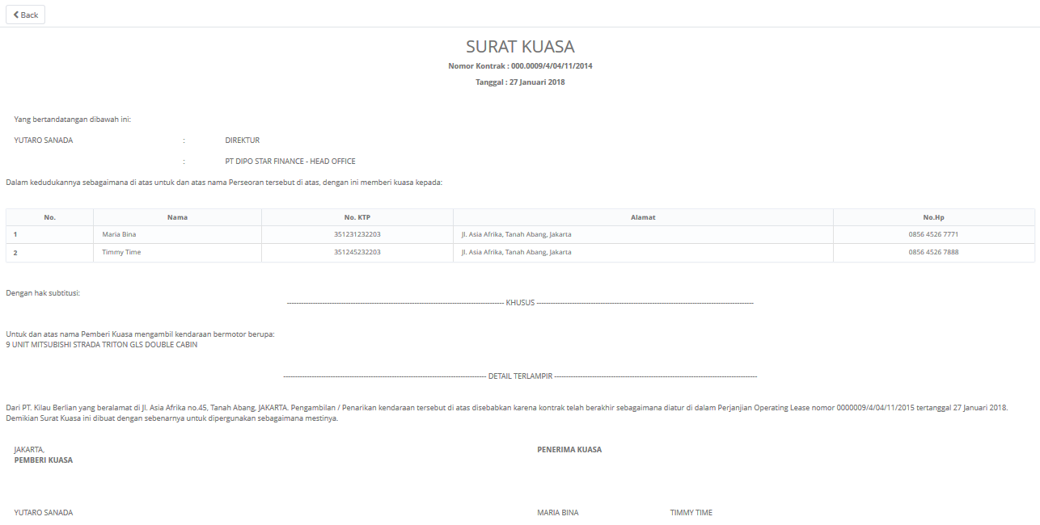

Screen 83: RAL form print preview

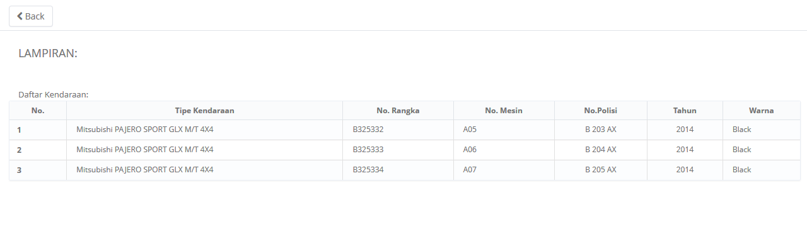

Screen 84: RAL attachment print preview

User can choose to print the RAL form, or save document as Excel or PDF.

## RAL History

User can check the revision date of RAL by navigating to RAL history. Click **RAL History** button on the selected RAL number.

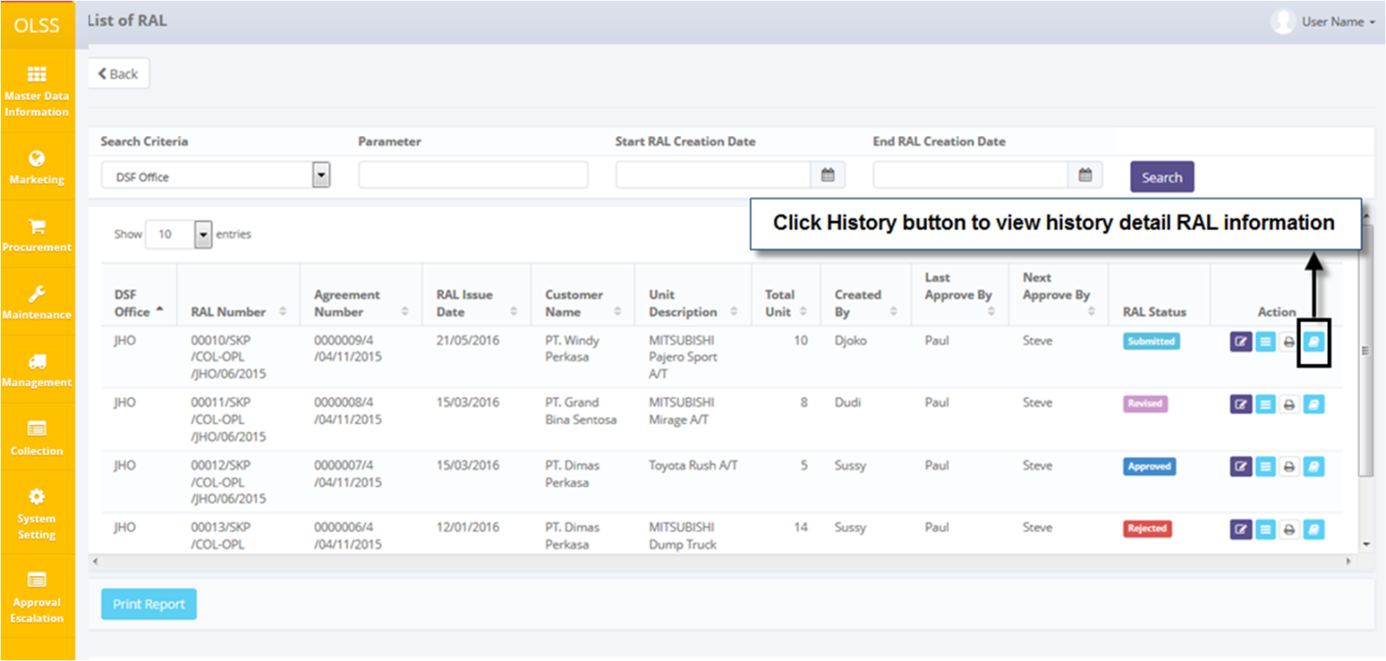

Screen 85: List of RAL – History button

System will navigate to RAL History screen.

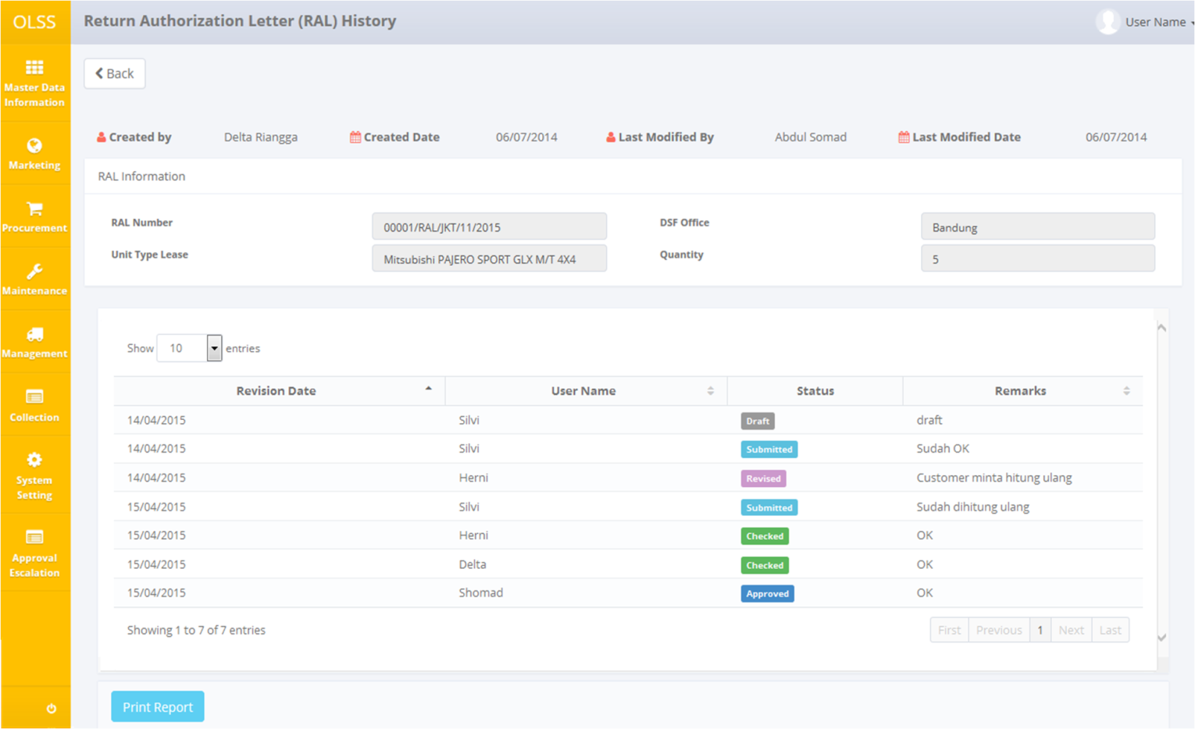

Screen 86: RAL history screen

## Print RAL Report

To print RAL report, user can access the feature from RAL History screen, or from List of RAL.

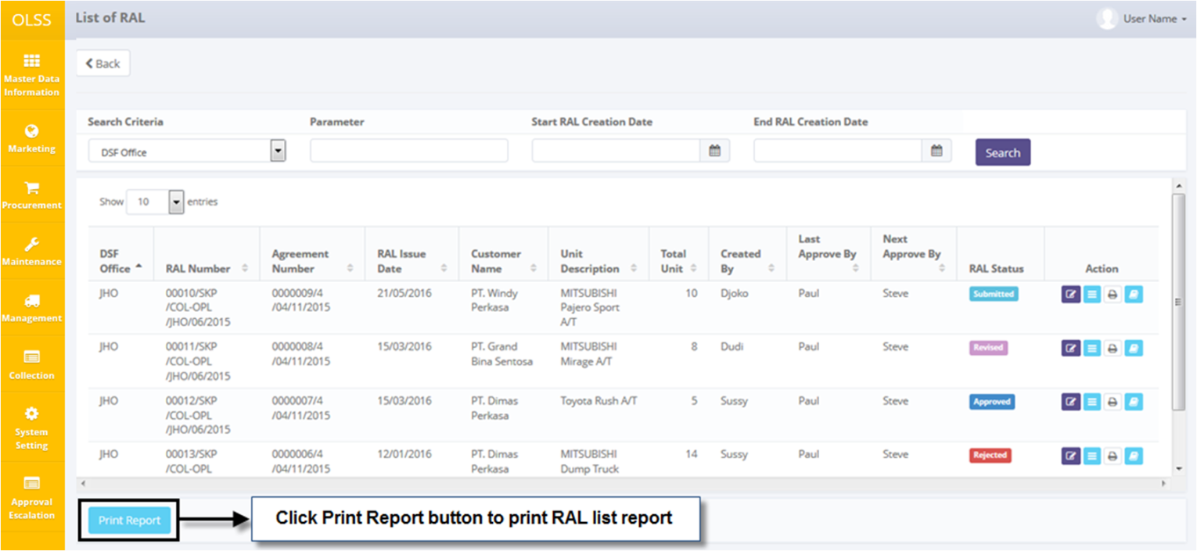

Screen 87: List of RAL – Print Report button

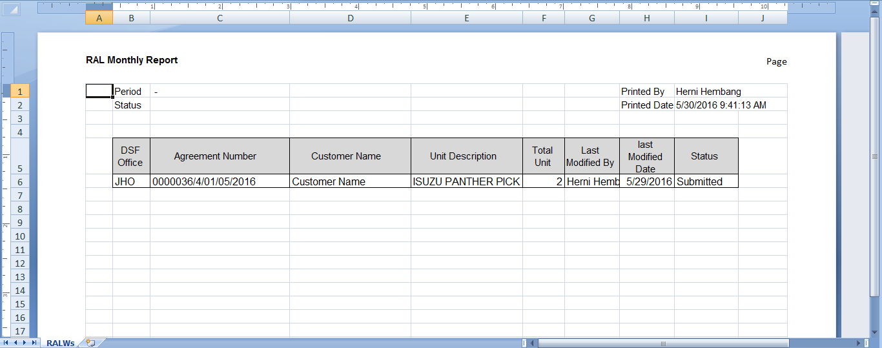

Screen 88: RAL Monthly Report

User can choose to print the RAL form, or save document as Excel.